
Computers & Industrial Engineering 209 (2025)
Contents lists available at ScienceDirect

Computers & Industrial Engineering

journal homepage: www.elsevier.com/locate/caie



Flight Cancellation Delay Prediction and Smart Flight Ticketing System with Machine Learning
Eda Nur Mutlu ª, Nuri Can Birdemir ª, Eyüp Emre Ülkü ª

ª Marmara University, Faculty of Technology, Turkey

A R T I C L E I N F O

Keywords:
Flight delay and cancellation prediction
Explainable AI (XAI)
XGBoost and SHAP values
Meteorological data integration
Imbalanced data classification
Air transportation analytics
Smart ticketing system
Web-based decision support
A B S T R A C T

Unanticipated flight cancellations and delays present significant operational and financial challenges for both passengers and airline companies. In this study, we propose a machine learning-based framework that predicts flight cancellations, delays, and cancellation reasons by integrating operational flight data with real-time meteorological conditions. The framework is built upon a large-scale dataset created by combining historical U.S. Department of Transportation (DOT) flight records with weather data obtained via the Meteostat API.
Comprehensive data preprocessing steps, including time normalization, feature engineering, and class imbalance handling with SMOTE, were implemented to improve model robustness. Several classification algorithms, such as XGBoost, Random Forest, Decision Tree, K-Nearest Neighbors, and Gradient Boosting, were evaluated using performance metrics including accuracy, precision, recall, F1-score, and ROC-AUC. The XGBoost model outperformed others, achieving high accuracy in predicting both cancellations and delays.
Unlike prior studies, our approach also incorporates a multiclass classification model to identify specific cancellation codes, enabling more actionable insights for airline operations. The proposed system demonstrates strong potential to be integrated into an intelligent flight ticketing platform, allowing passengers to make more informed booking decisions. This research contributes to the growing body of literature on AI-assisted transportation systems by combining data integration, ensemble learning, and explainable AI components to support proactive decision-making in air travel.

Introduction

Despite being a rapidly growing industry on a global scale, flight delays remain one of the most significant challenges facing the aviation sector. Flight delays directly affect passenger satisfaction while also causing economic losses for airlines and airports due to operational disruptions. Furthermore, delays intensify airport traffic, leading to chain delays and complicating airspace management (Li, Yao, 2025).
According to data published by the US Department of Transportation for 2023, only 78% of domestic flights operated by major airlines in the US departed on time. In other words, approximately 22% of flights departed 15 minutes or more behind schedule (U.S. Department of Transportation, 2024). A similar problem is evident in the United Kingdom: in 2023, 34% of passengers traveling from the UK encountered delays or cancellations, affecting a total of 45 million people, including 3.8 million who experienced complete cancellations. London Gatwick Airport, in particular, recorded the lowest on-time performance with a 42% delay rate (AirHelp, 2024). These statistics clearly reveal the global and persistent nature of the delay problem, emphasizing the need for effective predictive solutions in the sector.
The significant fluctuations in demand for air transportation during the pandemic have once again highlighted the importance of analyzing and forecasting flight delays and cancellations. To solve these complex problems, it has become inevitable to go beyond traditional approaches and use advanced technologies such as artificial intelligence and machine learning. In this context, the smart systems to be developed will provide strategic benefits that will both increase passenger satisfaction and improve the operational efficiency of airlines.
Within the scope of this study, a machine learning-based model capable of predicting flight delays and cancellations has been developed. One of the model's most significant innovative aspects is the comprehensive and multidimensional use of meteorological data. While there are studies in the literature that use weather data, this study offers a broader range of environmental data by obtaining nine different meteorological parameters (minimum/maximum temperature, precipitation, snow, wind direction/speed, maximum wind speed, atmospheric pressure, and sunshine duration) via the Meteostat API. The “weather composite score” derived from these parameters models the combined effect of factors such as precipitation, snow, wind, and temperature extremes into a single weighted score, reflecting the cumulative impact of different weather conditions on flight operations more realistically.

* Corresponding author at: Marmara University, Faculty of Technology, RTE Campus, Maltepe, Istanbul, Türkiye.
E-mail addresses: emre.ulku@marmara.edu.tr (E. E. Ülkü).
https://doi.org/10.1016/j.rtbm.2024.101161
Received 26 September 2023; Received in revised form 4 June 2024; Accepted 17 June 2024
Available online 22 June 2024
2210-5395/© 2024 The Author(s). Published by Elsevier Ltd. This is an open access article under the CC BY-NC-ND license (http://creativecommons.org/licenses/by- nc-nd/4.0/).

Another unique aspect of the study is the dynamic use of meteorological data not only in model training but also in the real-time forecasting stage. The developed web-based application provides up-to-date delay and cancellation risk forecasts by retrieving current weather conditions via the Meteostat API while passengers are selecting tickets. Additionally, weather data is used not only for delay prediction but also for classifying cancellation reasons (airline-related, weather-related, national air system-related, security-related). SHAP (Shapley Additive Explanations) and Feature Importance analyses were used to visualize the individual contributions of meteorological variables to model predictions, making the system explainable and interpretable. While the literature typically uses only historical flight data or operational variables, this study models the impact of environmental conditions in detail, offering a more comprehensive and realistic approach.
The developed model aims to improve the user experience by directly integrating flight delay predictions into the ticket sales platform. When passengers enter their flight information, they will be able to receive predictions about the risk of their flight being delayed and optimize their travel plans accordingly. Passengers will benefit from alternative flight suggestions, ticket price analysis, and better planning options based on delay risk. At the same time, airlines will be able to streamline their operational processes, better manage delay sources, and minimize revenue losses. Machine learning methods are a powerful tool for extracting meaningful information from large and complex data sets (L’heureux, Subramanian, Ghosh & Krishnamurthy, 2017). Within the scope of this study, the XGBClassifier algorithm was chosen to predict flight delays and cancellations. XGBClassifier stands out with its high accuracy rate and generalizability (Bentéjac, Csörgő & Martínez-Muñoz, 2019). In addition, the flexible structure of this algorithm allows the model to be continuously updated with new data, improving its future performance and providing a dynamic solution. Compared to traditional statistical methods, XGBClassifier demonstrates superior performance in multifactorial problems such as flight delays and cancellations due to its ability to model more complex relationships.
The study aims to create value for three main target groups:
1. Passengers: By receiving early warnings about the risk of delays, they will be able to plan their trips more consciously and access alternative flight options.
2. Airline Companies: by identifying operational bottlenecks, improving scheduling, and enhancing customer service delivery.
3. Airport Management and Civil Aviation Authorities: They will be able to make flight planning more efficient based on delay estimates.
In conclusion, this study utilizes the innovative capabilities provided by machine learning technologies in the search for solutions to flight delays. The study aims to present a model that will contribute to global air transportation and, in particular, respond to the operational challenges encountered in the post-pandemic period (Bartle, Lutte & Leuenberger, 2021).

  - Purpose and Importance of Project Work

The primary objective of this study is to develop a machine learning model capable of predicting flight delays, cancellations, and their causes in air transportation. Within the scope of this study, numerous factors affecting flight operations were systematically analyzed, and the complex relationships between these factors were modeled using machine learning algorithms. To examine the impact of weather data in particular, meteorological parameters obtained from the Meteostat API were integrated with flight data. This significantly improved the accuracy and generalizability of the prediction model, creating a decision system that could both increase passenger satisfaction and contribute to the operational decision-making processes of airlines.
In the technical aspect of the study, the performances of different machine learning algorithms were evaluated comparatively. In this context, the XGBClassifier, Random Forest Classifier, Decision Tree Classifier, KNN Classifier, and Gradient Boosting Classifier algorithms were used. Following the performance comparison of the algorithms, the model demonstrating the highest success was selected, and optimization studies were conducted on this model. Preliminary evaluations revealed that the XGBClassifier algorithm can effectively learn patterns in complex data sets and quickly adapt to new data. The developed model was evaluated using various performance metrics, ensuring continuous improvement in prediction accuracy.
In the practical application phase of the study, the developed prediction model was integrated into ticket sales platforms. Thanks to this integration, passengers were provided with delay risk assessments during the flight selection stage, alternative flight routes were suggested, and dynamic pricing strategies based on delay risk were developed. This approach enables passengers to plan their travel more consciously, while also contributing to increasing customer satisfaction for airlines.
From the perspective of airlines, the study aims to create a decision support system to increase operational efficiency. This system will enable early interventions to optimize operational costs and prevent delays by analyzing the root causes of delays. Thus, airlines will be able to improve their operational processes and gain a competitive advantage by making data-driven decisions.
This study makes concrete contributions to the academic literature, particularly in areas such as the integration of meteorological data into flight prediction models and the prediction of multi-class cancellation reasons. Weather variables, which are often overlooked in the literature, have been comprehensively addressed in this project and evaluated in a way that directly impacts model performance. Furthermore, with its ability to classify cancellation reasons, the study paves the way for artificial intelligence-based systems that can predict not only whether a delay will occur but also its cause. From a sectoral perspective, the developed model enables airlines to improve their delay risk analysis, provide more transparent information to passengers, and use it as a decision support system in flight planning. In these respects, the study serves as a strong reference for both academic research and digital transformation applications in the aviation sector.
The system architecture developed in the technical application dimension of the study has a three-tiered structure:
1. The Python/Flask-based model API layer includes trained XGBoost models and Meteostat API integration, providing a real-time prediction service.
2. The Node.js/Express-based backend layer handles user management, flight search services, and communication with the model API.
3. The React-based frontend layer manages the user interface and visualization of prediction results.

Thanks to this architecture, when passengers select a flight, the system automatically retrieves current weather data from the Meteostat API based on the selected date and airport information. It then transmits this data along with flight operational parameters (airline, distance, departure time, etc.) to the model, instantly providing users with delay and cancellation predictions. This integration has enabled the work to move beyond being merely an academic model and become a real-world application. Furthermore, the system's API-based modular structure allows for the integration of different weather services or additional data sources in the future and provides advantages in terms of scalability.

Literature review

Today, the rapidly increasing demand for air transportation has made the analysis of flight delays an important area of research (Çalış, Durmaz & Gencer, 2018). Researchers widely utilize machine learning and data mining techniques to predict flight delays. Studies in the literature have generally focused on factors such as the location of airport facilities, weather and airport capacity. Machine learning techniques make significant contributions in this field by enabling the storage and processing of large-scale data sets (Ghosh & Tabrizi, 2018). However, most of the existing research has focused on a specific geographical region or a limited number of factors, and has been lacking in the development of holistic approaches to delay prediction.
This study aims to provide a new perspective on forecasting models for flight delays. In order to fill the gap in the literature, a comprehensive dataset integrating various factors such as flight data as well as meteorological data is used. In particular, the use of comprehensive meteorological data sources such as Meteostat allows for more precise modeling of weather impacts. As emphasized in Delahaye and Puechmorel's study, weather factors are often neglected or superficially addressed in the literature, but in this study, the impact of weather factors on flight delays is analyzed in depth, improving the accuracy and reliability of the model (Delahaye & Puechmorel, 2020).
As Chawla et al. have shown, the problem of data imbalance has emerged as an important issue in the literature due to the fact that delays and cancellations involve rare observations (Chawla, Bowyer, Hall & Kegelmeyer, 2002). This paper aims to develop more balanced, generalizable and highly accurate forecasting models by addressing the data imbalance problem in a systematic way.
In their study, Khaksar and Sheikholeslami apply various machine learning algorithms to predict airline delays (Khaksar, & Sheikholeslami, 2017). Methods such as Decision Trees, Random Forest, Clustering and Bayesian classification were tested on the data obtained from the US and Iran flight networks and focused on predicting the causes of delays more accurately. In the US network, visibility and wind speed have a significant impact on delays, whereas in the Iranian network, factors such as fleet age and aircraft type stand out. In the predictions obtained, a hybrid classification with Decision Trees and Clustering methods was used and an accuracy rate of approximately 70% was achieved.
Bojia Ye et al. propose a methodology using supervised learning methods to predict flight delays at airports (Ye, Liu, Tian & Wan, 2020). In the study, operational flight data and weather information from Nanjing Lukou International Airport were processed and four types of airport-related features were generated for the prediction models. The study achieved high accuracy, especially in 1-hour delay forecasts, and the LightGBM model gave the best results with an accuracy of 86.55%. The results of this model emphasize the importance of forecasting based on operational and weather conditions. In a similar study, Atlıoğlu evaluated 11 different machine learning models using an operational dataset obtained from a leading airline in Turkey (Atlıoğlu, Bolat, Şahin, Tunalı & Kılınç, 2020). By comparing various performance metrics for each model, he tried to identify the most appropriate features in the dataset to achieve the highest accuracy.
Shahinaz M. Al-Tabbakh et al. applied various machine learning techniques to analyze flight delay data of EgyptAir (Al-Tabbakh, Mohamed & El, 2018). The main objective of the study was to determine the most appropriate classification algorithm for predicting flight delays. The researchers followed a methodology that included data preparation, using classification algorithms and evaluating model performance. Eight different classification algorithms (Decision Tree, Random Forest, REPTree, PART, Decision Table, OneR, JRip) WEKA data mining tool and compared them. The performance of the classification models was evaluated using accuracy, precision, recall, F1-score and ROC area metrics. According to the results of the analysis, the PART algorithm had the highest performance with an accuracy of 83.1%. On the other hand, the REPTree algorithm was identified as the leading tree-based classifier with an accuracy of 80.3% and the fastest running time. The study demonstrated the effectiveness of machine learning techniques in flight delay prediction and provided EgyptAir with important information to improve flight operations. The researchers plan to apply big data mining technologies using larger datasets in the future.
Kurt's study aims to predict flight delays using US domestic flight data (Kurt, 2019). For this purpose, various machine learning methods such as Decision Trees, Random Forest, Bagging, Extra Trees, Gradient Boosting and XGBoost classifier were tested. In the study, where these models were evaluated with success criteria such as accuracy, F1 score and recall, the highest accuracy rate was achieved by the Gradient Boosting algorithm with 71.72%. The study suggests that the prediction performance can be improved by incorporating different data features into the model.
In Tang's study, seven different classification algorithms were evaluated to predict flight delays using one-year data of flights departing from New York JFK Airport (Tang, 2021). Among these algorithms, Decision Tree achieved the highest success with an accuracy rate of 97.78%. In particular, Random Forest and Gradient Boosting methods, which are tree-based classifiers, were found to perform better than other basic classifiers. In the study, it was stated that the unbalanced distribution of the data was eliminated by measures such as weighted accuracy.
In their study published in Research in Transportation Business & Management, Wang et al. used the CNN-LSTM model to predict flight delays considering both spatial and temporal correlations. By integrating weather, seasonal effects, airport capacity and operational timeframes, the model achieved high accuracy in the real world (Wang et al., 2021).
Another paper proposed by Abdelghany et al. introduces a "parallel series data-driven model" approach to predict both the duration and the cause of IATA coded flight delays. They successfully predicted different subclasses of delays on international flights considering the airline network structure (Abdelghany et al., 2023).
Mueller and Chatterji investigated flight cancelations and delays with London Heathrow (LHR) airport data using machine learning-based classifiers. In this study, strategic flight scheduling for delays and cancellations was evaluated and performance analysis of the models on KPIs was presented to measure the robustness of the strategies (Mueller & Chatterji, 2020).
A paper by Truong analyzed flight delay risk with causal machine learning techniques. This study not only focused on prediction accuracy, but also conceptualized the structural causal relationships of the key parameters leading to delay and constructed "cause-and-effect" networks (Truong, 2020).
Table 1 provides a comparative overview of recent and prominent studies on flight cancellation and delay prediction. The machine learning techniques used in each study, the data sources, the problems focused on, and the success rates achieved are analyzed. Thus, the similarities and differences between the prominent approaches in the existing literature and the methods used in this project are more clearly revealed.
Table 1
Comparative Literature Table: Flight Cancellation and Delay Forecasting Studies.
Study | Method / Algorithm | Advantages | Disadvantages | Performance / Results
Delahaye & Puechmorel | ML model with weather integration | Detailed weather modeling - Data-driven analysis | Focusing only on certain factors | Model sensitivity increased, ROC-AUC not specified
Chawla et al. | Random Forest, Clustering, Bayes | Attention to data imbalance - Hybrid classification | Average accuracy is low | ≤ 70% accuracy
Khaksar & Sheikholeslami | Decision Trees, RF, Clustering | Comparison of US/Iran networks - Factor diversity | Weak multi-model framework | USA: Wind effect, Iran: Fleet age decisive
Bojia Ye et al. | LightGBM | 4 feature groups created - 1-hour predictions successful | Single airport (Nanjing) focused | Accuracy: 86.55
Atlıoğlu (TR) | 11 different ML models | Model comparisons made - Focused on feature extraction | Model names and results not detailed | Optimal model selection made
Al-Tabbakh et al. | DT, RF, REPTree, PART vb. (WEKA) | Comparison of 8 algorithms - metrics such as ROC, F1 used | Limited to Egyptian data only | PART: %83,1, REPTree: %80,3 accuracy
Kurt (2022) | RF, XGBoost, Bagging, GBM | Experiment with US domestic data - detailed F1 and recall measures | Accuracy is relatively low | The best: Gradient Boosting %71,72
Tang (JFK) | 7 different algorithms | Promotion of tree-based models - Data imbalance-weighted solution | Single airport data | Decision Tree: %97,78 accuracy
Mueller & Chatterji (2020) | Random Forest, SVM | Heathrow data - Delays and cancelations forecast together | Model details limited | ROC-AUC not specified, binary estimation approach
Abdelghany et al. (2023) | Ensemble, Parallel Series Model | Joint estimation of lag time and cause - Feature importance analysis | Based on IATA coded flights only | Strong performance in multiple classes, no details given
Truong (2020) | Causal Trees, SHAP | Support for causal analysis - Cause and effect inference | High computational load, focused only on latency | High explainability, accuracy rate not specified
Wang et al. (2021) | CNN-LSTM (spatio-temporal) | Deep learning - Time-space interaction modeling | Network structure sensitive to variability | Accuracy 84%+, ROC-AUC not specified

In recent years, studies that not only model with machine learning but also integrate these models into systems that are open to user interaction have gained importance. In particular, "smart ticketing systems" and web-based artificial intelligence applications have become one of the basic building blocks of decision support systems in the airline industry.
Alfarhood et al. integrated a flight cancellation and delay prediction model developed using US flight data with a web-based dashboard. Through this platform, users can monitor flight-based forecast results in real time. The system aims to support user decisions by visualizing the outputs of the model (Alfarhood et al., 2024).
Similarly, in AeroPredict, delay prediction models developed using meteorological data and historical flight records are made accessible through a web interface where users can search for flights. In this study, risk levels based on model outputs were presented graphically and model confidence scores were also included in the system (Hake et al., 2024).
Biman Barua and Kaiser proposed a more comprehensive solution and developed a smart ticketing system based on AI + Microservice + Blockchain architecture. In this system, an AI-powered recommendation engine provides personalized ticket recommendations and flight forecasts by analyzing past bookings and user behavior. Ticket offers are dynamically updated based on model outputs. In this respect, the study makes an important contribution to the holistic design of predictive systems that directly affect the user experience (Barua & Kaiser, 2024).
These recent literature examples are similar to our ticketing system and show that this work fills the gaps in the literature with not only the model performance but also the real-time web-based prediction system offered to the user.
Table 2 reviews the recent studies on Smart Airplane Ticketing Systems and comparatively evaluates the technologies used, intended functionalities, data sources and innovative approaches presented. The table systematically summarizes the developments in this field, especially in areas such as user-oriented prediction systems, dynamic pricing algorithms, reservation optimization and artificial intelligence-assisted flight planning. Thus, the unique contributions of the system proposed in the project can be seen more clearly by comparing it with similar applications in the literature.
Table 2
Comparative Literature Table: Smart Airfare Ticketing Systems.
Study | Methods Used | Advantages | Disadvantages | Performance / Results
Alfarhood et al. (2024) | ML-based latency prediction + Web dashboard | Real-time forecasting interface - Visualization support - Decision support via Dashboard | Only delay estimate (no cancellation)- Model details shared limited | ROC-AUC: ~0.89, Dashboard user satisfaction 85
IRE Journals (AeroPredict, 2024) | LightGBM + Weather data + Web UI | Flight search + Forecast system integrated- Weather dynamic effect | Limited explainability of the prediction result - User is not given a confidence score | Accuracy: 86.5%, Web access: ✓
Barua & Kaiser (2024) | AI suggestion system + Microservices + Blockchain | Personalization & recommendation engine- Secure booking- Flight + user data analysis together | Complex system structure - Model details explained in limited detail | 80% recommendation accuracy, high security due to blockchain integration
SmartTicket | XGBoost + Multi-tier system (Model API + Backend + Frontend) | Multiple models including cancellation, delay and reason for cancellation - Prediction with confidence + detail panel - Model insights via UI | Resource requirements may increase in case of full integration in real data | Cancellation ROC-AUC: 0.95, Delay accuracy: 82%+, Positive feedback in web user testing

This multifaceted approach, which includes the integration of meteorological data, the use of advanced machine learning algorithms and the systematic treatment of the data imbalance problem, aims to develop more accurate and generalizable forecasting models that will improve operational processes in the airline industry. Considering the limitations of existing studies in the literature, this study is expected to make significant contributions both theoretically and practically. In particular, the comprehensive integration of meteorological data and the use of modern machine learning techniques have the potential to provide a new framework for future research.
Within the scope of this research, studies published between 2018 and 2024 that examine machine learning approaches on flight cancellation, delay and smart ticketing system were systematically analyzed. It was found that the majority of the reviewed studies focus on a single airline or airport, make limited use of meteorological data, and do not adequately address the problem of data imbalance. Most existing studies only consider data limited to specific geographical regions or a single set of factors and do not adequately consider broad data integration. Moreover, although the problem of data imbalance is a common obstacle in the literature, modern techniques have not been sufficiently applied in this context.
In this study, unlike other studies, the parameters used in flight delay prediction are diversified and extended. While developing the prediction model, parameters such as flight code, weather conditions (e.g. wind speed, temperature, precipitation), cancellation/delay rates of previous flights, aircraft type and flight density were taken into consideration. However, instead of simply categorizing flight delays as "present" or "absent", predictions were made in specific minute intervals. For example, the probability of a flight experiencing a delay of 15-30 minutes or more than 30 minutes can be predicted based on the confidence rate of the model. This approach provides more detailed and actionable outputs on delay forecasting, differing from previous studies that focused only on flight cancellations.
Furthermore, in this study, extensive data integration is achieved, bringing together flight data and comprehensive meteorological data sources such as Meteostat. This approach allows for more precise modeling of the impact of weather factors on flight delays. The problem of data imbalance is addressed by using modern data processing techniques such as SMOTE and the performance of the model is improved.
In conclusion, this study aims to fill the gap in the literature and provide a balanced, highly accurate and reliable model for predicting flight delays. In addition, the proposed model is expected to provide an important basis for future research due to its detailed prediction capabilities and wide data integration.

Dataset and models

In this section, the dataset, data preprocessing stages and supervised learning models used in this study will be explained in detail. First, the dataset consisting of flight and weather data will be introduced and how these data are integrated will be explained. Then, the data preprocessing process will be discussed and the steps taken to address issues such as missing data, outliers and imbalanced data will be explained. Finally, we will focus on the supervised learning algorithms (e.g., XGBClassifier, Random Forest, and XGBoost) used to build prediction models and explain how these models are trained and evaluated. In this way, the methodological approach of the study and the techniques used will be comprehensively presented.
The dataset used in this study includes flight delay and cancellation data from 2016 to 2024, provided by the United States Department of Transportation and the Bureau of Transportation Statistics. The dataset is based on the DOT's "On-Time: Reporting Carrier On-Time Performance" database (1987-present) and includes variables such as flight routes (departure and arrival points), event time intervals (minutes, local time), and reasons for delays and cancellations. These data were created by combining 3 open source data. First, canceled and non-canceled flight data was obtained from the open dataset provided by Patrick Zelaya. The dataset contains 1,360,878 rows and 32 columns of flight information (Zelaya, 2023). Another dataset is taken from the dataset shared by Threnjen, which contains only canceled flights and consists of 64,097 rows (Threnjen, 2019). The last dataset contains 21,824 rows of flight information of only canceled flights from open data provided by Shubham Singh (Singh, 2024). In total, the final combined dataset obtained from the 3 datasets consists of 1,446,799 rows. Detailed attributes for these 3 datasets are presented in Table 3.
Weather is one of the main external factors that directly affect the timeliness of flights, especially through parameters such as wind speed, temperature, precipitation, snow and visibility (Kim, Mavris & Zachariah, 2021). The often limited use of such environmental data in the literature reduces the sensitivity of forecasting models to real-world conditions. For this reason, the study combines flight data with weather data obtained from the Metostat library. The Metostat library allows the study of the impact of weather conditions on flight delays and cancellations with meteorological data collected on a daily basis using geographical coordinates for each airport. The integration of these two datasets is an important step towards a more comprehensive analysis of flight performance.
The data source used in the study, the Meteostat library, provides weather data from various meteorological stations. These data include basic meteorological parameters that can directly affect aviation operations such as daily minimum and maximum temperature (°C), total precipitation (mm), snowfall (mm), wind direction (0-360°), average and maximum wind speed (km/h), average sea level pressure (hPa) and total daily sunshine duration (minutes). These data, collected on a daily basis using geographic coordinates for each airport, are integrated with the main dataset to analyze the impact of weather conditions on flight delays and cancellations. This integration allows for a more comprehensive examination of the factors affecting the performance of flight operations.

Table 3
Comparative Literature Table: Smart Airfare Ticketing Systems.
 | Updated Title | Source Title | Data Type |  | Description
0 | FL_DATE | FlightDate |  | object | Flight date
1 | AIRLINE | Airline |  | object | Name of the airline
2 | AIRLINE_DOT | AirlineDot |  | object | DOT identifier for airline
3 | AIRLINE_CODE | Reporting_Airline |  | object | Name of the airline
4 | DOT_CODE | DOT_ID_Reporting_Airline |  | int64 | DOT identifier for airline
5 | FL_NUMBER | Flight_Number_Reporting_Airline |  | int64 | Flight number
6 | ORIGIN | Origin |  | object | Departure airport code
7 | ORIGIN_CITY | OriginCityName |  | object | Departure airport city
8 | DEST | Dest |  | object | Destination airport code
9 | DEST_CITY | DestCityName |  | object | City of arrival airport
10 | CRS_DEP_TIME | CRSDepTime |  | int64 | Planned departure time
11 | DEP_TIME | DepTime |  | float64 | Actual departure time
12 | DEP_DELAY | DepDelay |  | float64 | Departure delay
13 | TAXI_OUT | TaxiOut |  | float64 | Time spent taxiing
14 | WHEELS_OFF | WheelsOff |  | float64 | When the wheels of the airplane leave the ground
15 | WHEELS_ON | WheelsOn |  | float64 | When the wheels of the airplane touch the ground
16 | TAXI_IN | TaxiIn |  | float64 | Time spent taxiing
17 | CRS_ARR_TIME | CRSArrTime |  | int64 | Planned arrival time
18 | ARR_TIME | ArrTime |  | float64 | Actual arrival time
19 | ARR_DELAY | ArrDelay |  | float64 | Arrival delay
20 | CANCELLED | Cancelled |  | float64 | Indication of whether the flight has been canceled (1 for canceled, 0 for not canceled)
21 | CANCELLATION_CODE | CancellationCode |  | object | Reason for cancellation (if applicable)
22 | DIVERTED | Diverted |  | float64 | Indication of whether the flight was diverted or not (1 for diverted, 0 for not diverted)
23 | CRS_ELAPSED_TIME | CRSElapsedTime |  | float64 | Planned elapsed time
24 | ELAPSED_TIME | ActualElapsedTime |  | float64 | Actual elapsed time
25 | AIR_TIME | AirTime |  | float64 | Time spent in the air
26 | DISTANCE | Distance |  | float64 | Distance traveled
27 | DELAY_DUE_CARRIER | CarrierDelay |  | float64 | Delay due to carrier
28 | DELAY_DUE_WEATHER | WeatherDelay |  | float64 | Delay due to weather conditions
29 | DELAY_DUE_NAS | NASDelay |  | float64 | Delay due to National Airspace System (NAS)
30 | DELAY_DUE_SECURITY | SecurityDelay |  | float64 | Delay due to security reasons
31 | DELAY_DUE_LATE_AIRCRAFT | LateAircraftDelay |  | float64 | Delay due to late arrival of the plane

Based on preliminary analyses conducted on the original dataset, a 15-minute threshold was used to classify flight delays. According to this approach, flights with delays exceeding 15 minutes were labeled as “1” (delayed), while those with delays of 15 minutes or less were labeled as “0” (on time). Figure 1 visually presents the distribution of delay statuses based on this binary classification. This visualization is important in that it shows which criteria were used when creating the model's target variable.
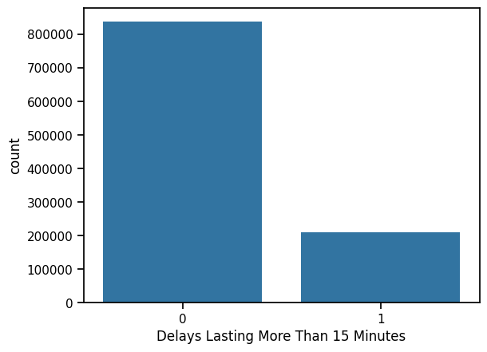
Fig. 1. Delay Status Graph.
In Figure 2 visually represents the distribution of the number of flights experiencing delays of more than 15 minutes by different airlines in a horizontal bar chart format. The graph comparatively shows which airlines stand out in terms of the number of delayed flights. It is particularly evident that large-scale airlines such as American Airlines Inc., Southwest Airlines Co., and Delta Air Lines Inc. have significantly higher values in the number of flights experiencing delays exceeding 15 minutes compared to other companies. This situation indicates that these companies experience delays in their operational processes, along with their high flight volume. In contrast, smaller companies such as Horizon Air, Allegiant Air, and ExpressJet Airlines have had a limited number of delays. The graph provides important visual data for evaluating delay analyses on an airline basis.

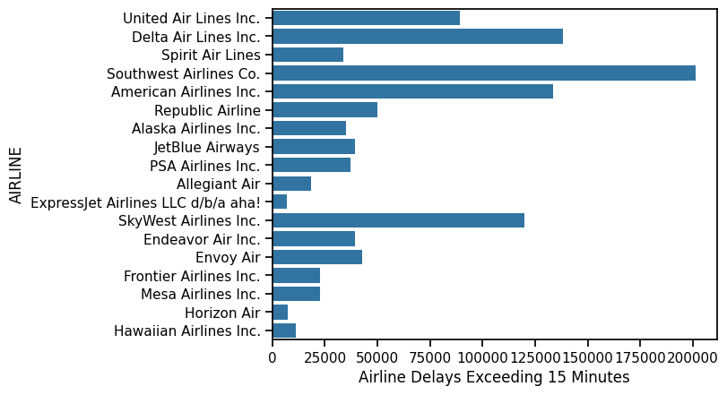
Fig. 2. Delay Status Graph by Airline Companies.
Based on our dataset, the maximum delay factor distribution was examined as shown in Figure 3. As a result, it was determined that 34.1% of delays were caused by carriers, 33.6% by the national aviation system, 29.5% by late aircraft departures, and 2.7% by weather and security issues.
The delay factor distribution in Figure 3 provides important insights that will affect the performance of machine learning models. The 34.1% delay rate caused by the carrier requires sensitive feature extraction in model training. The 33.6% delay caused by the national aviation system tests the models' ability to capture complex systemic relationships. The 29.5% of aircraft delays highlights the importance of time series and sequential dependency modeling. Low-rate weather and safety delays (2.7%) indicate class imbalance issues, revealing the necessity of data balancing techniques such as SMOTE.

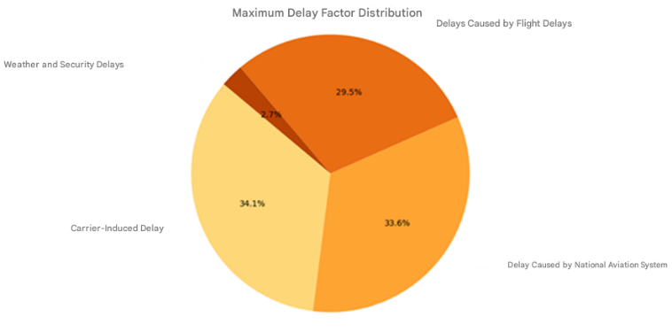
Fig. 3. Delay Factor Distribution.
The heatmap of delay factors in Figure 4 visually represents the correlations of flight delays with each other. The intensity of the colored cells indicates the strength of the relationships between the factors, which plays a critical role in feature selection for machine learning models and in understanding multivariate interactions.
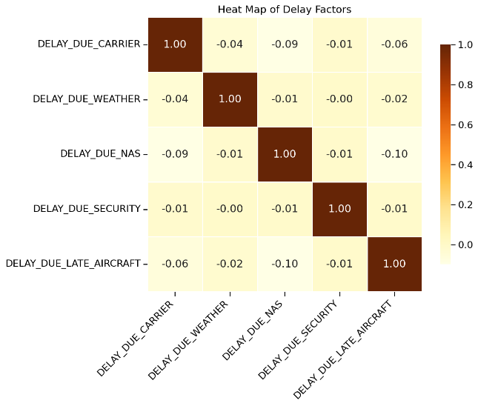
Fig. 4. Heatmap of Delay Factors.
  - Meteorological Data Integration and Processing Process

Weather, particularly parameters such as wind speed, temperature, precipitation, snow, and visibility, is one of the main external factors that directly affect the timely execution of flights (Kim, Mavris & Zachariah, 2021). The limited use of such environmental data in the literature often reduces the sensitivity of prediction models to real-world conditions. Therefore, in this study, flight data and meteorological data obtained from the Meteostat library were combined through a systematic integration process.
Meteorological data integration was carried out as a multi-stage process. In the first stage, the geographic coordinates (latitude and longitude) of each airport were determined using the Nominatim API. Nominatim is a free geocoding service provided by the OpenStreetMap project and was used to convert ORIGIN_CITY (departure city) information into geographic coordinates. This step was performed to obtain the latitude and longitude information required for the Meteostat API to provide weather data for a specific location.
In the second stage, meteorological data was retrieved using the coordinates obtained via the Meteostat library. Meteostat is an open-source Python library that provides weather data collected from thousands of meteorological stations worldwide. In this study, weather data specific to the date and city of departure was queried for each flight using the FL_DATE (flight date) and ORIGIN_CITY (city of departure) information. Nine different meteorological parameters were obtained on a daily basis using Meteostat's Daily class:
• tmin: Daily minimum temperature (°C)
• tmax: Daily maximum temperature (°C)
• prcp: Total precipitation amount (mm)
• snow: Snowfall amount (mm)
• wdir: Wind direction (0-360°)
• wspd: Average wind speed (km/h)
• wpgt: Maximum wind speed (gust, km/h)
• pres: Average sea level pressure (hPa)
• tsun: Total daily sunshine duration (minutes)

In the third stage, the retrieved meteorological data was merged with the original flight dataset. Considering the size of the dataset (over 1.4 million rows), the data merging process was performed using a chunk processing strategy. This approach ensured uninterrupted data processing while optimizing memory usage. The merging process was performed using the merge function of the pandas library on the FL_DATE and ORIGIN_CITY columns. This automatically matched the meteorological conditions recorded in the city of departure and on that date for each flight record.
During the merging process, some flights were identified for which data could not be retrieved from the Meteostat API (e.g., small airports or regions with missing data). These mismatched records were stored in a separate file for data quality tracking, and an imputation strategy was applied using median values from SimpleImputer for missing meteorological values. This ensured the integrity of the dataset and minimized the risk of models encountering missing data.

  - Data Preprocessing

The success of machine learning models depends heavily on the effectiveness of the data preprocessing phase (Dumitrascu & Aiordachioaie, 2022). In this study, a comprehensive data preprocessing strategy is applied to improve the accuracy of flight delay predictions. In particular, we focus on the integration of meteorological data and the improvement of data quality.
In the first stage of data preprocessing, the integration of meteorological data into flight data was performed. In this process, the Meteostat library was used to obtain detailed weather information for each flight point. For meteorological data integration, the geographical coordinates of the airports were first determined through Nominatim API. The coordinate information obtained was converted into meteorological data points using Meteostat's Point class. For each flight date, critical meteorological parameters such as minimum temperature, maximum temperature, precipitation, snowfall, wind direction, wind speed, wind speed, wind speed, atmospheric pressure and sunshine duration were collected.
In the process of combining meteorological data with flight data, a chunk processing strategy was adopted considering the size of the data set. This approach optimized memory usage and ensured that the data processing process continued without interruption. The data were matched on the 'FL_DATE' and 'ORIGIN_CITY' columns, and the unmatched records were stored in a separate file for data quality monitoring.
The final version of the dataset is shown in Table 4 with the addition of detailed weather information for each flight point using the Meteostat library.
Table 4
Structure of the Model Training Data Set.
 | Updated Title | Source Title | Data Type | Description
1 | FL_DATE | FlightDate | object | Flight date
2 | AIRLINE_CODE | Reporting_Airline | object | Name of the airline
3 | ORIGIN_CITY | OriginCityName | object | Departure airport city
4 | DEST_CITY | DestCityName | object | City of arrival airport
5 | CRS_DEP_TIME | CRSDepTime | int64 | Planned departure time
6 | DEP_TIME | DepTime | float64 | Actual departure time
7 | CRS_ARR_TIME | CRSArrTime | int64 | Planned arrival time
8 | CANCELLED | Cancelled | float64 | Indication of whether the flight has been canceled (1 for canceled, 0 for not canceled)
9 | CANCELLATION_CODE | CancellationCode | object | Reason for cancellation (if applicable)
10 | DISTANCE | Distance | float64 | Distance traveled
11 | TMIN | tmin | float64 | Minimum temperature (Celsius)
12 | TMAX | tmax | float64 | Maximum temperature (Celsius)
13 | PRCP | prcp | float64 | Amount of precipitation (mm)
14 | SNOW | snow | float64 | Amount of snowfall (mm)
15 | WDIR | wdir | float64 | Wind direction (degrees)
16 | WSPD | wspd | float64 | Wind speed (m/s)
17 | WPGT | wpgt | float64 | Wind speed (m/s)
18 | PRES | pres | float64 | Atmospheric pressure (hPa)
19 | TSUN | tsun | float64 | Total insolation time (hours)

A thorough analysis and cleaning process was applied for missing values in the dataset. Missing data distributions and patterns were analyzed to determine whether the missing values were random or systematic. Missing values in numerical variables were filled with the median, while the mode was used for categorical variables. Features with more than 30% missing data were removed from the dataset, while missing values in meteorological data were filled with values from the nearest timestamp in accordance with the time series character.
A multifaceted approach was adopted for outlier detection and processing. Statistical methods such as Z-score and IQR methods, visual analysis techniques such as box plots and scatter plots, and domain knowledge-based controls were used together. For delay times, values greater than 24 hours and outliers in meteorological data were analyzed in detail. As a result of the analysis, outliers that contributed significantly to the data set and were considered statistically reasonable were retained, while anomalies caused by incorrect data entries were corrected with appropriate methods.
In order to improve model performance, a comprehensive data analysis and the derivation and processing of explanatory variables for forecasting were applied. Time-based features include time of day, day of the week, day of the week, holiday information and seasonal information. Meteorological features include new features such as categorical variables derived from weather data, wind intensity categories and visibility classification. Operational features include airport congestion indicators, previous flight delays and route-specific historical performance metrics.
In the data standardization and normalization phase, problems arising from the scale differences of numerical features were addressed. For continuous variables, standardization was applied using StandardScaler, while variables with a limited range were normalized to the range [0,1] with MinMaxScaler. Categorical variables were digitized with the One-Hot Encoding method.
The problem of imbalance between delay classes is addressed. Using the SMOTE algorithm, the minority class samples were synthetically augmented and the class weights parameter was adjusted to obtain a balanced data set. These extensive preprocessing steps enabled the model to utilize the training data more effectively and make more reliable predictions in real-world applications.
In the data preprocessing process for the cancellation and delay reason prediction model, the temporal data was first parsed. The 'FL_DATE' column was converted to datetime format and year, month and day information were extracted as separate features. For categorical variables, the airline code (AIRLINE_CODE), departure city (ORIGIN_CITY) and destination city (DEST_CITY) were converted into numeric values using LabelEncoder. Missing values in the CANCELLATION_CODE column were filled with the value 'N' (no cancellation) and encoded.
The imbalance problem in the dataset is addressed using the SMOTE algorithm. For the cancellation case, the sampling_strategy=0.5 parameter was used to synthetically increase the minority class samples, while the 'auto' strategy was used for the cancellation reason classification. To fill in missing data, a median strategy was applied with SimpleImputer, followed by scaling of features with StandardScaler.
In the data preprocessing process for the delay prediction model, canceled flights were first removed from the dataset. Temporal data were similarly disaggregated and categorical variables were transformed with LabelEncoder. Delay times were categorized into four different classes:
• Class 0: On time or early (≤ 0 minutes)
• Class 1: Slight delay (1-15 minutes)
• Class 2: Medium delay (16-30 minutes)
• Class 3: Serious delay (>30 minutes)
Missing values were filled with median values using SimpleImputer and features were normalized using StandardScaler. The class imbalance problem was solved using the SMOTE algorithm with the parameter k_neighbors=5. In this process, a balanced data set was obtained by creating an equal number of samples for each delay class.
Feature importance levels for both models are analyzed and visualized. This analysis allowed to identify the most important factors affecting the prediction performance of the models and to evaluate feature selection strategies. The data preprocessing steps were implemented in a systematic and repeatable way using the Pipeline structure of the scikit-learn library. The whole process is illustrated in the flowchart in Figure 5.
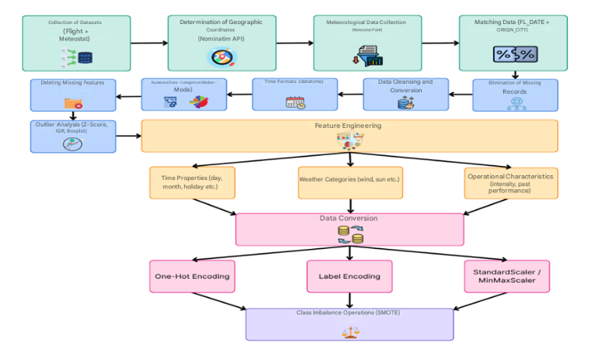
Fig. 5. Data Preprocessing Flow Diagram.
This detailed data preprocessing process enabled the models to utilize the training data more effectively and significantly improved their prediction performance. In particular, solving the class imbalance problem and feature engineering steps contributed to more reliable predictions in real-world applications.

  - Supervised Learning Models

Machine learning is the general name for algorithms that enable computers to analyze data, discover possible patterns and make predictions using these patterns. These algorithms, which can provide information about the relative difficulty of learning in different environments, are divided into several categories (Oladipupo, 2010). The two most common types of machine learning algorithms are supervised and unsupervised learning. Supervised learning algorithms create a function that transforms inputs into desired outputs. The main types of supervised learning include regression and classification. Unsupervised learning focuses on modeling a set of inputs without labeled examples.
In this study, a supervised learning approach is adopted and machine learning is used to predict flight cancelations and delays. Since the input data and the target outputs (e.g. delay class or cancellation status) are known, supervised learning algorithms are appropriate in this context. They are ideal tools for modeling complex relationships in airline operations and analyzing the impact of a large number of variables (Kumar & Singh, 2020).
The Decision Tree algorithm is a machine learning approach that solves classification and regression problems by partitioning data in a hierarchical structure. Each node represents the decision-making process on a feature and the structure of the tree is built based on the most discriminative features. It provides a clear visualization of the impact of different factors in flight delay prediction (Breiman, 1984).
LightGBM is a high-performance and efficient machine learning algorithm that works within the Gradient Boosting framework. It stands out with its ability to train quickly on large data sets and optimize memory usage. It can achieve higher accuracy rates compared to other algorithms on complex and high-dimensional data sets such as flight delay (Ke et al., 2017).
Random Forest is an ensemble learning method that combines multiple Decision Trees (Breiman, 2001). Each tree is trained by bootstrap sampling and random feature selection, thus reducing the risk of overfitting. In flight delay prediction, it provides more reliable results by making predictions over different sub-data sets (Kumar & Singh, 2020).
Clustering algorithms allow to discover hidden patterns by grouping data points with similar characteristics. Bayesian classification combines prior knowledge and observational data in a probabilistic approach. These methods play a complementary role in understanding the complex relationships in flight delays (Breiman, 2001).
XGBoost is a very popular and powerful algorithm in machine learning, especially known for its ability to predict with high accuracy on large data sets (Chen & Guestrin, 2016). An improved version of Gradient Boosting techniques, XGBoost improves the overall accuracy of the model by adding new trees to correct the model's errors at each iteration. This feature is particularly useful for problems such as flight forecasting, which are characterized by complex relationships and the influence of multiple factors. In the case of flight cancellation and flight delay forecasts, the XGBoost algorithm is an effective tool for modeling the complex structure of the data, which is influenced by multiple factors (Oladipupo, 2010).
In order to obtain accurate results in flight cancelation and flight delay forecasting, it is necessary to be careful in choosing the algorithm. The XGBoost algorithm used here was chosen for two particularly important features:
Events such as dealing with class imbalance, flight cancellations and delays are often associated with imbalanced data sets. For example, the number of canceled flights may be much less than the number of operated flights. XGBoost can effectively manage such imbalances and more accurately learn the minority class.
High performance and flexibility, XGBoost is an algorithm capable of making fast and accurate predictions on large data sets. Especially for data sets that depend on many factors, such as flights, XGBoost's powerful feature engineering and model optimization capabilities are very useful.
Therefore, XGBoost has been chosen as an ideal option for achieving high accuracy in imbalanced datasets and modeling complex relationships.
This section details the data processing and modeling process we applied for flight cancellation and cancellation code prediction. First, the date columns in the flight data were separated into year, month, and day, and time-related features were extracted. Categorical data was converted to numerical data using LabelEncoder. This process allowed the model to understand the data more easily.
Unnecessary columns in the dataset that were not required for training the model, such as airline code, departure and arrival cities, were removed. The target variables were defined as flight cancellation status and cancellation code. The dataset was then split into training and test sets, and missing values were imputed using the median value to ensure data consistency. The training data was scaled using StandardScaler to ensure the model was trained more smoothly.
Resampling was performed using the SMOTE method to ensure balanced training of the model. This step was performed to eliminate class imbalance and ensure that the model learned each class equally. The XGBoost algorithm was chosen as it is an algorithm that can handle class imbalance and achieves high success in large data sets.
The accuracy rates of the trained models were evaluated on the test set. During this evaluation, accuracy rates were measured separately for cancellation status and cancellation code predictions. The results showed that both models had high accuracy rates. Furthermore, model performance was examined in depth using classification reports and ROC-AUC scores.
In this study, the reason for adopting two separate model architectures for flight cancellations is primarily that the operational use cases differ. Airlines and passengers primarily want to receive early warnings about whether a flight will be canceled. At this early warning stage, the reason for the cancellation may not yet be clear, or operational priorities may not require this information. The dual model enables proactive measures to be taken by detecting the risk of cancellation with high accuracy. The reason for cancellation is usually used after the cancellation decision has been made, during the reporting and customer notification phase. Therefore, a two-stage prediction structure offers a solution that is more suitable for real-world workflows.
Second, model interpretability and calibration performance have been improved. While the binary classification model learns the general characteristics of cancellation events (e.g., seasonality, airport congestion, meteorological conditions), the multi-class model focuses on modeling the complex relationships specific to each cancellation reason. By using separate models, the hyperparameters and threshold values of each model can be optimized independently. This allows for optimizing the accuracy of the binary model while improving the precision of the multi-class model.
Thirdly, performance improvement has been achieved in minority classes. In the two-stage approach, since each model can independently optimize SMOTE parameters and class weights for its target variable, a more balanced performance has been achieved in minority classes. Specifically, removing canceled flights from the dataset in the cancellation reason model enabled SMOTE to generate more realistic synthetic samples and reduced model imbalance.
For these reasons, the two-stage model architecture was found to be more advantageous in terms of both academic performance metrics and practical operational use and was adopted as the main approach of the study.
The feature importance scores of the model are visualized in Figures 6 and 7, showing which features are more influential in the model's predictions. This visualization helped us better understand how the model works. A function was developed to predict cancellation status and cancellation codes for new flight data, enabling real-time predictions.
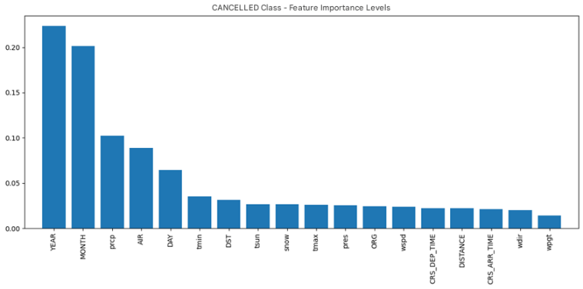
Fig. 6. Flight Cancellation Prediction Model Feature Importance.
Fig. 7. Flight Cancellation Code Prediction Model Feature Importance
The modeling process for flight delay prediction involves similar steps. We performed the necessary date transformations on the data, checked whether flights were canceled or not, and removed canceled flights from the dataset. Time-related features such as year, month and day were created over the date column, and categorical data were converted into numerical data. Missing data was filled with the median strategy using SimpleImputer and features in the dataset were scaled with StandardScaler.
Flight delay times were categorized into classes as the target variable. Classification was based on the delay time of flights as on-time, slight delay, moderate delay and severe delay. The class distribution in the dataset was reviewed and class imbalance was detected. The training set was resampled using SMOTE to train the model in a balanced way.
In the model training phase, the XGBoost classifier model was selected and the parameters of the model were optimized. After the training process, the model was evaluated on the test set and accurate classifications were obtained. The accuracy rate and performance of the model were analyzed with confusion matrix, classification report and accuracy score. In addition, in order to determine which features of the model are more important, the importance levels of the features are visualized and the bar graph of the impact of these features on predictions is presented in Figure 8.
Fig. 8. Flight Delay Prediction Model Feature Importance.
Finally, a sample data set was created to make predictions with the new flight data and the predictions of the model were performed. These predictions include the possible class of flight delay and the probabilities of each class. The accuracy and reliability of the model were checked through these predictions.
The main reason for choosing XGBoost as the algorithm of choice is its high performance, especially on large datasets, and its ability to effectively manage class imbalance. Moreover, the feature importance visualizations provided by XGBoost make the decision-making processes of the model more understandable and enable it to be successfully applied to complex problems such as flight forecasting.

  - Supervised Model Update and Maintenance Strategy

Given the dynamic nature of flight operations and meteorological patterns, a systematic update and maintenance strategy is critical to preserving the long-term performance of the developed machine learning models (Gama, Žliobaitė, Bifet, Pechenizkiy & Bouchachia, 2014). Changes in airline operational procedures over time, new airport infrastructure investments, updates to air traffic management systems, and the impact of climate change on meteorological patterns can cause discrepancies between the model's training data and real-world conditions (Lu, Liu, Dong, Gu, Gama & Zhang, 2018). Therefore, a proactive retraining and monitoring protocol has been adopted to sustain the model's predictive power.

    - Periodic Retraining Cycle

The three-month retraining cycle forms the basis of the model maintenance strategy. This period allows for observing the reflection of seasonal variations on model performance and ensures sufficient accumulation of new data. Each quarter, the model is retrained using the last 12 months of flight data and related meteorological records. In line with temporal validation principles, this approach separates the most recent three months of data as the test set, while using the previous nine months of data as the training set. This preserves the model's ability to continuously make “future predictions” and minimizes the risk of memorizing past data.

Results

In this section, the results of machine learning studies on flight cancellations, cancellation reason codes and flight delays in the airline industry are examined in detail. The findings are analyzed in line with the definition and objectives of the research problem and compared and evaluated with similar studies in the literature.

  - Flight Cancellation Forecasting Model Results

The model developed for predicting flight cancelations showed a very high accuracy rate. The 97% accuracy rate obtained for the CANCELLED class shows the overall success of the model. This result shows that the model developed for predicting flight cancelations in the aviation industry has a high performance.
In the performance evaluation on the test set, a precision of 98% and a recall of 99% were obtained for the prediction of non-canceled flights (class 0). This result shows that the model can detect non-canceled flights with high accuracy. On the other hand, for the prediction of canceled flights (class 1), precision is 88% and recall is 77%. Considering the unbalanced class distribution in the dataset, these values reveal the model's performance in detecting the minority class.
The F1-score, as the harmonic mean of precision and recall metrics, is calculated as 0.98 for non-canceled flights and 0.82 for canceled flights. The ROC-AUC score is 0.88, which proves that the model significantly outperforms random predictions.
Despite the unbalanced class distribution in the dataset (1,316,842 non-canceled flights versus only 129,957 canceled flights), the fact that the model achieved such a high overall accuracy shows the effectiveness of the algorithm and data preprocessing techniques used.

  - Cancellation Code Prediction Model Results

The model developed for predicting the cancellation codes of canceled flights achieved an accuracy rate of 74%. This rate can be considered as a very successful result for a multi-class classification problem in predicting between five different cancellation code classes. The model classification according to the delay time of the flights is as shown in Table 5.
Table 5
Cancellation Code Prediction Model Output Classes and Description.
Class | Class Code | Code Description
0 | A | Airborne/Carrier-borne
1 | B | Weather-driven
2 | C | Sourced from the national weather system
3 | D | Security-related
4 | N | Other

When the performance of the model is analyzed on a class basis, outstanding results are obtained with 77% precision and 88% recall, especially for the cancellation code number 3. The F1-score for this code was calculated as 0.82. For cancellation code 1, a satisfactory performance was also observed with 84% precision and 83% recall. These results demonstrate the model's ability to predict certain revocation codes.
However, for revocation code number 4, the model showed a lower performance (24% precision, 32% recall). This can be explained by the fact that this abort code has characteristics that can be confused with other codes or is underrepresented in the dataset. However, in general, the model performed well in predicting cancellation codes in the aviation industry.
When the weighted average values are analyzed, precision is 75%, recall is 74% and F1-score is 74%. These values indicate that the model performs strongly for a multi-class prediction problem.

  - Flight Delay Estimation Model Results

The model developed to predict flight delays achieved an accuracy rate of 74.58%. This rate can be considered as a very successful result in predicting between four different delay categories.
When the confusion matrix in Figure 9 is analyzed, it is seen that the model performs particularly well in predicting delay categories 0 and 1.
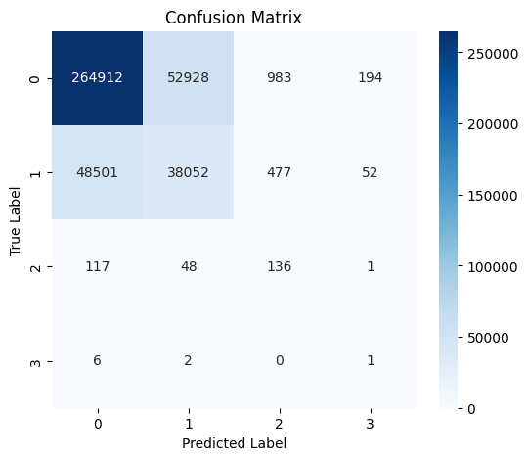
Fig. 9. Flight Delay Prediction Model Complexity Matrix.
For the flight delay prediction model results, precision 84%, recall 83% and F1-score 84% were calculated for category 0. For category 1, precision is 42%, recall is 44% and F1-score is 43%. These results emphasize the strong performance of the model in predicting the most common lag categories.
On the other hand, the model performance is lower for lag categories 2 and 3. Especially for category 3, low values such as precision 0%, recall 11% and F1-score 1% are observed. This is due to the underrepresentation of these categories in the dataset (1,595,643 for category 0, 434,981 for category 1, 1373 for category 2 and only 50 samples for category 3). Nevertheless, the overall accuracy of the model is 74.58%, indicating that it can be used as a powerful tool for delay prediction in the aviation industry.
When weighted average values are analyzed, precision, recall and F1-score are calculated as 75%. These values prove that the model performs well overall.

  - Model Optimization and Evaluation Techniques

In our work, a comprehensive set of techniques is used to improve the performance of the models and avoid overlearning. In particular, the regularization parameters for the XGBoost algorithm have been rigorously optimized.

    - Temporal Cross-Validation Results

To evaluate the generalization ability and temporal consistency of our models, a 5-fold temporal cross-validation technique based on TimeSeriesSplit was applied. Unlike traditional cross-validation, this technique splits the dataset chronologically and tests the model's ability to learn from past data and predict future data in each iteration. This approach eliminates temporal leakage risk, reflecting the model's performance in real-world scenarios more realistically (Cerqueira, Torgo & Mozetič, 2020). To prevent this temporal bias and ensure realistic prediction performance, all our models were trained in earlier years (2016–2022) and evaluated in later years (2023–2024). The traditional K-Fold Cross-Validation method, which involves random data shuffling, can artificially produce high performance metrics by ignoring the time series characteristics of flight data.
Temporal cross-validation analysis for the cancellation prediction model revealed the performance variation of the model across different time periods. The model achieved an average accuracy rate of 91.67% ± 3.67%. The fluctuation between a minimum of 86.37% and a maximum of 96.36% indicates the impact of seasonal factors and operational conditions on model performance. The stability of the accuracy metric indicates that the model's overall prediction capability is consistent over time.
However, high variation was observed in the precision, recall, and F1-score values, which are critical metrics for the minority class (cancellation cases). The average precision was measured as 36.50% ± 35.65%, the average recall as 18.58% ± 24.01%, and the average F1-score as 18.90% ± 29.70%. These high standard deviations reflect the variability of cancellation rates during test periods and the difficulty of predicting rare classes. Due to the temporal validation strategy, the cancellation rate can be very low (2-3%) in some folds, while higher (8-10%) in others. This demonstrates the model's adaptation capacity across different operational periods.
The average ROC-AUC score was calculated as 66.43% ± 13.36%. This value indicates that the model's ability to detect cancellation cases is at a moderate-to-good level.
Temporal cross-validation results for cancellation reason classification revealed the complexity of the multi-class problem. The model achieved an average accuracy rate of 52.87% ± 27.45%. The wide standard deviation and minimum-maximum range indicate that the model's performance varies across different time periods. This situation stems from the heterogeneity in the temporal distribution of cancellation reasons.
For example, while weather-related cancellations (code B) are dominant in winter months, airline operational cancellations (code A) may increase in summer months. Temporal validation tests the model's ability to learn from one season and predict another, revealing its sensitivity to class distribution changes.
Temporal cross-validation analysis for delay classification revealed the highest performance variation. The model achieved an average accuracy rate of 54.83% ± 32.77%, precision of 82.31% ± 24.28%, recall of 54.83% ± 32.77%, and an F1-score of 55.28% ± 32.74%. The maximum values of 100% stem from the small size or homogeneous structure of the test set in certain folds. The very low minimum values indicate that the class distribution in some temporal folds showed significant differences between training and testing.
This high variation reveals that delay conditions are strongly influenced by seasonal, daily, and hourly factors. In particular, temporal validation results may show that rare delay classes (e.g., severe delays) are absent or represented by very few examples in some test folds. This means that the model encounters different data distributions during training and testing, reflecting real-world dynamics.

    - Training and Test Accuracy Comparison

To check whether our models suffer from overlearning, we compared the training and test accuracies. For the flight cancellation prediction class, the training accuracy is 95% and the test accuracy is 97%. The fact that the difference is only 2% proves that the model does not suffer from overlearning problems and even performs better on the test set. This shows that the model's ability to generalize to real-world data is strong.
For the flight cancelation code prediction class, the training accuracy was 90% and the test accuracy was 74%. The difference of 16% indicates that there may be some overlearning for this model. However, for a multi-class classification problem, a test accuracy of 74% can still be considered a successful result. We also optimized the regularization parameters of the XGBoost algorithm to reduce this difference.

    - XGBoost Regularization Optimization

In order to prevent overlearning, the regularization parameters of the XGBoost algorithm, namely gamma, min_child_weight, max_depth and lambda, were carefully adjusted. In particular, we reduced the complexity of the model by decreasing the max_depth parameter and enhanced the L2 regularization by increasing the lambda parameter. These optimizations allowed our models to generalize better.
Furthermore, a manually developed cross-validation function (manual_cross_val_score) was used to overcome the memory issues encountered with standard cross-validation functions. This function used the StratifiedKFold class to partition the dataset in a stratified way so that each class is proportionally represented in each fold. This approach allowed us to obtain more reliable results, especially with imbalanced datasets.

    - Operational Importance of Rare-Class Predictions

Successfully identifying rare classes in flight delay and cancellation predictions is a critical indicator of system performance (Chawla, Bowyer, Hall & Kegelmeyer, 2002). Although serious delays (8%) and cancellations (3%) constitute minority classes in the dataset, they represent the costliest scenarios for airline operations and have the most negative impact on passenger satisfaction (Eurocontrol, 2019). The application of the SMOTE algorithm has significantly increased the predictability of these rare events (Fernández, García, Galar, Prati, Krawczyk & Herrera, 2018).
Particularly in predicting low-frequency but high-impact events such as weather-related cancellations, the experience synthetic examples add to the model paves the way for proactive decision-making in real-world applications (Kim, Choi, Briceno, & Mavris, 2016). In model evaluations, the recall and F1-score metrics obtained for minority classes indicate that the system is ready for operational use (Sokolova & Lapalme, 2009). This success is a direct result of the careful selection of SMOTE parameters and comprehensive validity checks of synthetic samples (He & Garcia, 2009). Future work plans include comparative analyses using advanced sampling techniques such as ADASYN (Adaptive Synthetic Sampling) (He, Bai, Garcia & Li, 2008) and cost-sensitive learning methods (Elkan, 2001).

    - Model Performance and Explainability

In this study, two different machine learning models are developed to predict critical situations such as flight cancellations and delays that directly affect the operational processes of airline transportation. The models were trained with large-scale flight and meteorological datasets, and performance evaluations were carried out in a multidimensional way with basic metrics such as accuracy, precision, sensitivity, scenario-based analysis, explainable artificial intelligence (XAI), error distribution and business impact calculations.
It was observed that the flight cancellation model developed a robust decision mechanism in high-risk scenarios and produced remarkable results, especially in cases such as bad weather conditions and airlines with low reliability. On the other hand, the model's cautious approach in cases where cancellations are rare leads to a decrease in the sensitivity level.
Furthermore, the performance of the model in different operational scenarios (e.g. bad weather, short haul flights, reliable and problematic airlines) was analyzed. Especially in the cases labeled "bad weather" and "problematic airline", the model made very successful predictions with an F1 score exceeding 84%, while in the "reliable airline" scenario, the sensitivity value decreased significantly due to the rarity of cancellations. This reveals that the model develops a more cautious and sensitive decision mechanism especially in risky scenarios. The model performance in different scenarios is presented in Figure 10 and it is seen that the model makes more accurate predictions in high-risk conditions.
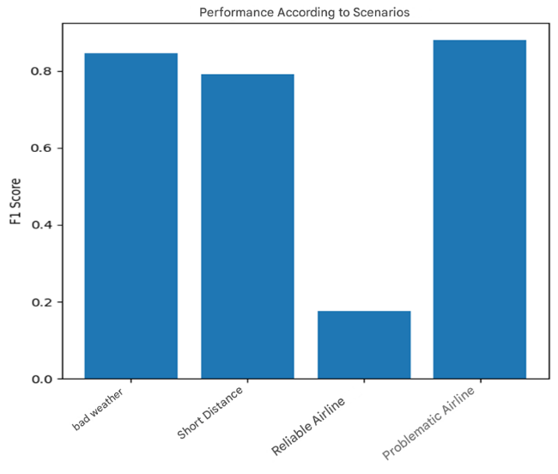
Fig. 10. F1 Score of Flight Cancellation Prediction Model According to Different Scenarios.
Explainable AI (XAI) techniques were used to understand which variables were more decisive in the model's forecasting decisions. According to the feature importance ranking, the most influential factors were flight year, weather, season, rainfall, airline reliability score and scheduled departure time. These results show that flight cancelations are shaped by both historical trends and environmental conditions.
The global interpretability of the cancellation prediction model was further enhanced using SHAP (SHapley Additive exPlanations) values. Figure 11 presents the SHAP summary plot, which illustrates the contribution of each input variable to the model's output. Features such as YEAR_NORMALIZED, precipitation (prcp), MONTH, WEATHER_COMPOSITE, and AIRLINE_RELIABILITY emerged as the most impactful variables in determining cancellation likelihood. The color gradient reflects the feature value (high in red, low in blue), while the x-axis represents the SHAP value, indicating the direction and magnitude of the feature's influence. This visualization demonstrates how environmental and temporal variables jointly shape the model's predictions.
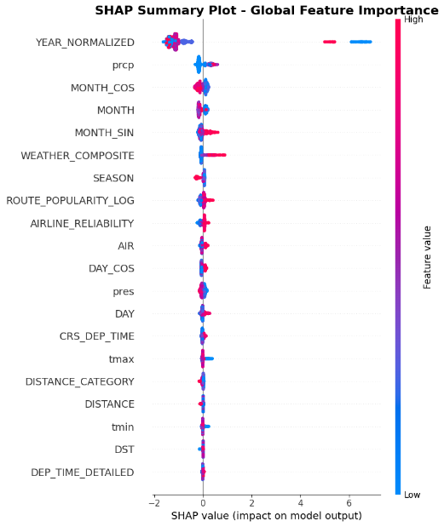
Fig. 11. SHAP plot showing the most influential features in the LDA model.
Within the scope of error analysis, false positive (FP=2001) and false negative (FN=11865) examples were analyzed and it was evaluated that if the model predicts a flight as canceled when it is not canceled, unnecessary alarms may be given to the passenger, resulting in negative impacts such as customer dissatisfaction, operational confusion and waste of resources. On the other hand, failure to detect actual cancellations (FN) may lead to more severe consequences such as passenger victimization and financial compensation. In this context, the threshold value of the model was tested with different scenarios and the optimal threshold value was determined as 0.40, which optimizes both business costs and performance metrics. This threshold was set in such a way that the model maintains its overall performance while reducing false negatives. As shown in Figure 12, with a threshold of 0.40, the model is balanced and cost efficient.
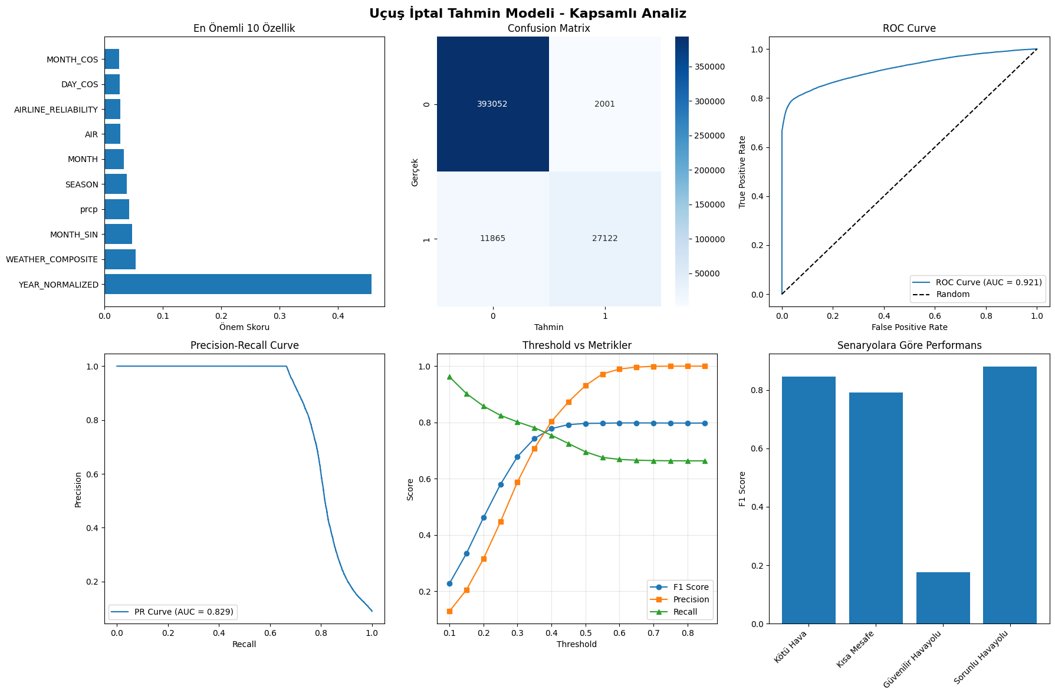
Fig. 12. Changes in Performance Metrics of Flight Cancellation Prediction Model According to Different Threshold Values.
The reliability of the model was tested with bootstrap and cross-validation techniques and it was observed that the model produced similar accuracy and F1 scores in different data samples. In particular, the accuracy within the 95% confidence interval remains within the [0.9675, 0.9685] band, indicating the generalizability and stability of the model. As a result of the business impact analysis, the potential annual gain of the model is calculated as approximately 1.5 billion dollars. This gain strongly supports the applicability of the model as a decision support mechanism in flight planning, resource allocation and passenger information systems.
The second model for flight delay prediction presented a more complex prediction problem due to its multi-class structure and data imbalance. While the model produced good results especially in the common delay classes, it showed low discrimination in the infrequently observed classes. This suggests that the model has difficulty in learning sparse classes.
In the explanatory analysis of the model, the most effective variables were found to be flight year, airline code, scheduled departure time, distance and various weather parameters. In the scenario-based analysis, it was found that the model gave more balanced results in cases such as short-haul flights, bad weather conditions and night flights; however, these results were not as strong as the cancellation model. Model performance in different scenarios is presented in Figure 13.
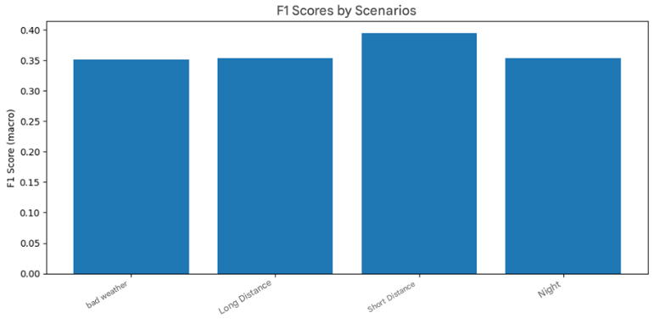
Fig. 13. F1 score of Flight Delay Prediction Model According to Different Threshold Values.
Additionally, SHAP values were used to interpret the delay prediction model. Figure 14 presents the global feature importance plot, which demonstrates how each input feature contributes to the model’s predictions across all delay categories. Notably, CRS_DEP_TIME, DISTANCE, and meteorological features such as WSPD (wind speed) and PRCP (precipitation) played a significant role in the model's output. This interpretability helps in understanding the reasons behind the model’s classification decisions and supports trust in real-world deployments.
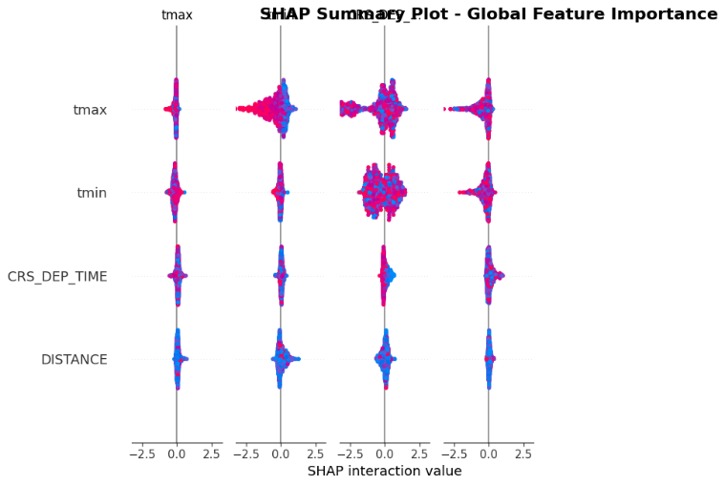
Fig. 14. SHAP summary showing the most important inputs in the lag forecasting model.
The error analysis is discussed in detail and the distribution of misclassified instances is analyzed. For example, 52,928 on-time flights were classified as slightly delayed, while 48,501 delayed flights were predicted on time. Such errors can result in misdirection in customer information systems and operational costs. Within the scope of the business impact analysis, it is predicted that this model has a negative net impact in the short term, but may become functional if the classes are simplified and modeled with a binary structure.
Both models provide a more comprehensive framework than many studies in the literature with the ability to analyze large-scale flight and meteorological data. The flight cancellation model has a very strong structure in terms of both its technical achievements and its potential for integration into decision support systems. Although the delay model produced more limited results due to its more complex prediction objective and class imbalance, it provided important data insights.

  - Literature Review and Comparative Analysis of Project Success Values

In this section, we present the results of the developed flight cancellation, cancellation code and flight delay models obtained with different machine learning algorithms and compare them with similar studies in the literature.

    - Results of the Success Values of the Developed Model

The performance of the model was evaluated using algorithms such as XGBoost, Random Forest, Decision Tree, KNN and Gradient Boosting Classifier. Table 6, Table 7 and Table 8 present the metrics such as accuracy, precision, recall, f1-score and ROC-AUC obtained by the developed models with different machine learning algorithms.
Table 6
Flight Cancellation Prediction Model Performance Results.
Model | Accuracy | Precision | Recall | F1-Score | ROC-AUC
XGBoost | 0.97 | 0.98 | 0.99 | 0.98 | 0.92
Random Forest | 0.97 | 0.97 | 0.99 | 0.98 | 0.85
Decision Tree | 0.95 | 0.98 | 0.96 | 0.97 | 0.88
KNN | 0.95 | 0.99 | 0.96 | 0.97 | 0.91
Gradient Boosting | 0.97 | 0.97 | 1.00 | 0.98 | 0.83

According to the results presented in Table 6, XGBoost, Random Forest and Gradient Boosting algorithms achieved the highest accuracy rates in flight cancellation prediction (97%). These three models also performed very well in terms of precision, recall and f1-score.
The XGBoost model provided the best discrimination power with a value of 0.92 in the ROC-AUC metric. The Random Forest model had similar accuracy and f1-score values and achieved a competitive ROC-AUC value of 0.85. Although the Decision Tree and KNN models were slightly lower in terms of overall accuracy, the KNN model in particular stood out as an important alternative for flight cancellation prediction, achieving the highest value (0.91) in the ROC-AUC metric compared to the other models. Figure 15 shows the ROC curve and shows that the model offers a strong discrimination performance.
Fig. 15. ROC Curve And AUC Score For Flight Cancellation Prediction Model.
The Gradient Boosting model was the most successful model in detecting flight cancelations, with a recall rate of 100%. However, its ROC-AUC score of 0.83 was behind some other models. This shows that the overall predictive power of the model can still be improved.
These results show that ensemble learning methods such as XGBoost and Random Forest are highly effective for flight cancellation prediction.
Table 7
Cancel Code Forecast Model Performance Results.
Model | Accuracy | Precision | Recall | F1-Score | ROC-AUC
XGBoost | 0.74 | 0.84 | 0.88 | 0.83 | 0.87
Random Forest | 0.65 | 0.87 | 0.97 | 0.86 | 0.85
Decision Tree | 0.65 | 0.86 | 0.96 | 0.85 | 0.88
KNN | 0.61 | 0.83 | 0.69 | 0.73 | 0.83
Gradient Boosting | 0.65 | 0.85 | 0.98 | 0.85 | 0.82

According to the results presented in Table 7, the XGBoost model was the most successful algorithm in predicting the abort code with 74% accuracy. It also performed well in terms of precision, recall and f1-score metrics, achieving the highest discrimination power with a ROC-AUC score of 0.87.
Although the Random Forest and Decision Tree models achieved very high recall rates (97% and 96%), their overall accuracy remained at 65%. This indicates that the models were successful in correctly identifying the cancellation codes, but their overall classification accuracy was low. The Gradient Boosting model performed similarly, achieving 65% accuracy, close to Random Forest and Decision Tree.
The KNN model underperformed the other algorithms in terms of accuracy (61%) and f1-score (73%). In particular, the recall rate of 69% indicates that the model has difficulty in detecting some abort codes. In terms of the ROC-AUC metric, it offers an acceptable discrimination power of 0.83.
These results show that XGBoost is the most successful model for cancellation code prediction and that ensemble learning methods (XGBoost, Random Forest, Gradient Boosting) offer significant advantages in such multi-class classification problems.
Table 8
Flight Delay Prediction Model Performance Results.
Model | Accuracy | Precision | Recall | F1-Score | ROC-AUC
XGBoost | 0.75 | 0.84 | 0.83 | 0.84 | 0.80
Random Forest | 0.64 | 0.84 | 0.70 | 0.76 | 0.78
Decision Tree | 0.56 | 0.83 | 0.63 | 0.71 | 0.72
KNN | 0.71 | 0.87 | 0.75 | 0.80 | 0.78
Gradient Boosting | 0.47 | 0.74 | 0.58 | 0.65 | 0.65

According to the results presented in Table 8, the XGBoost model was the most successful algorithm in flight delay prediction with 75% accuracy. It also showed the most balanced performance in terms of precision (84%), recall (83%) and f1-score (84%) values and showed high discrimination power with 0.80 in the ROC-AUC metric. In Figure 16, the multiclass prediction performance of the model is also evaluated with the help of ROC curves. AUC (Area Under Curve) values for each delay class are calculated and presented visually. The ROC curves show the discrimination capacity of the model between classes, and high discrimination successes were observed especially in the moderate and severe delay classes.
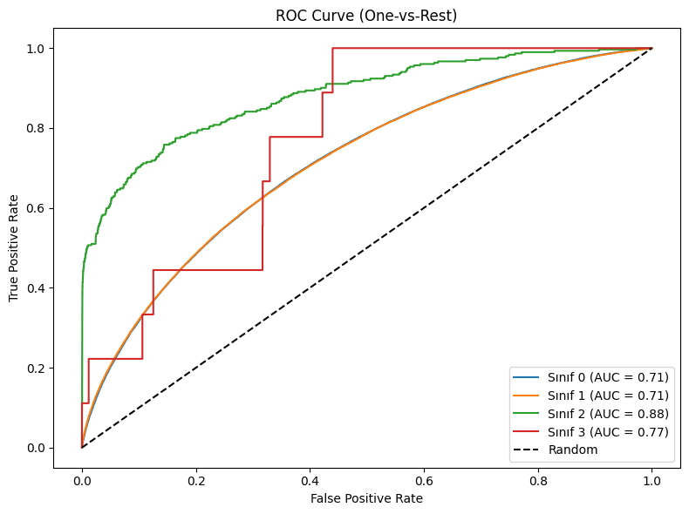
Fig. 16. Multiclass ROC Curve for Flight Delay Prediction Model (One-vs-Rest).
Although the Random Forest model achieved a precision of 84%, its recall was 70% and its overall accuracy was 64%. This indicates that the model was relatively successful in identifying delays but missed some cases. The Decision Tree model fell short of expectations with one of the lowest accuracy rates of 56%.
The KNN model performed better than Random Forest in terms of accuracy (71%) and f1-score (80%), but lower than XGBoost. In particular, the precision value of 87% indicates that most of the delays predicted by the model are correct. However, the recall value of 75% indicates that the model missed some lags.
The Gradient Boosting model showed the lowest performance with 47% accuracy. The recall value was 58% and the ROC-AUC score was 0.65, indicating that this model is inadequate in predicting flight delays.
Overall, XGBoost performs the best in flight delay prediction, while KNN and Random Forest also give reasonable results.

    - Comparison with the Success Values of Similar Projects in the Literature

For comparison, the methods, datasets, evaluation metrics and success rates used by the studies in the literature are analyzed. Then, a comparison is made with the results of our own study using the same or similar metrics.
Khaksar and Sheikholeslami used large-scale datasets of US and Iranian airline networks to predict flight delays (Khaksar & Sheikholeslami, 2017). As can be seen in Table 9, the performances of various machine learning algorithms are compared. In the study, algorithms such as J48 Decision Tree, K-Means Clustering, Bayes Classifier, Random Forest and Hybrid Method (Decision Tree + Clustering) were used and the highest accuracy was 71.39% with the hybrid method.
Table 9
Performance Results of Khaksar and Sheikholeslami Study.
Model | Accuracy (US) | Accuracy (Iran) | Min Recall  (%) | Max Recall (%) | Min Precision (%) |  | Min Precision (%)
J48 Decision Tree | 64.28 | 70.87 | 53.86 | 91.24 |  | 48.69 |  | 72.66
K-Means Clustering | 62.27 | 69.63 | 50.07 | 88.99 |  | 53.27 |  | 72.26
Bayes Classifier | 61.35 | 70.17 | 48.61 | 94.01 |  | 51.94 |  | 76.35
Random Forest | 67.43 | 72.11 | 52.34 | 83.78 |  | 51.37 |  | 75.15
Hybrid Method | 71.39 | 76.44 | 60.19 | 94.54 |  | 60.28 |  | 79.37

In our FCDP-SFTS (Flight Cancellation Delay Prediction - Smart Flight Ticketing System) study, thanks to the advanced techniques and ensemble learning approaches applied especially in the data preprocessing phase, we achieved 75% accuracy in the flight delay prediction model with XGBoost. These results show an improvement of 3.61% respectively compared to the study in the literature.
The dataset used in Kurt's study is based on open-source data provided by the US Bureau of Transportation Statistics and the Federal Aviation Administration (FAA). The dataset contains information on US domestic commercial flights operated in August 2018. After cleaning, the dataset consists of 638,776 rows and 18 columns. In the dataset, 38.29% of the flights were found to be delayed (Kurt, 2019).
Supervised machine learning methods such as Decision Trees, Random Forest, Bagging Classifier, Extra Extra Trees, Gradient Boosting and XGBoost Classifiers were used to predict flight delays. Metrics such as accuracy, recall and F1-Score were used for model performance evaluation. The success metrics obtained as a result of modeling with default parameters are shown in Table 10. The best results were obtained with Gradient Boosting and XGBoost models. In particular, the Gradient Boosting model was determined as the most successful method with 71.72% accuracy and 57.40% F1-Score.
Table 10
Performance Results of M.Kurt's Study.
Score Name | Model | Score
Accuracy  Scores | Decision Tree | 0.6777
Accuracy  Scores | Random Forest | 0.6808
Accuracy  Scores | Extra Trees | 0.6686
Accuracy  Scores | Bagging | 0.6867
Accuracy  Scores | Gradient Boosting | 0.7172
Accuracy  Scores | XGBoosting | 0.7165
Recall  Scores | Decision Tree | 0.3854
Recall  Scores | Random Forest | 0.3939
Recall  Scores | Extra Trees | 0.3099
Recall  Scores | Bagging | 0.4091
Recall  Scores | Gradient Boosting | 0.4971
Recall  Scores | XGBoosting | 0.4934
F1 Scores | Decision Tree | 0.4783
F1 Scores | Random Forest | 0.4862
F1 Scores | Extra Trees | 0.4176
F1 Scores | Bagging | 0.5002
F1 Scores | Gradient Boosting | 0.5740
F1 Scores | XGBoosting | 0.5716

In our FCDP-SFTS (Flight Cancellation Delay Prediction - Smart Flight Ticketing System) study, although similar data features were used, a more extensive data preprocessing and feature engineering process was applied. An accuracy of 75% was achieved with the XGBoost algorithm. These results show an improvement of 3.28% respectively compared to the study in the literature.
Yu Yanying et al. aimed to predict flight cancelations using 5 million flight data from 2016 in the USA (Yu, Mo & Li, 2019). The dataset contains 65 variables such as flight date, airline information, departure and arrival times, delay reasons (weather, security, airline-induced, etc.) and flight distance. After feature selection, 11 important variables were used in the model.
Logistic Regression, SVM (Support Vector Machines), Naive Bayes and Decision Tree were used as prediction models. Model performances were evaluated with metrics such as accuracy, PR (precision - recall), AUC (ROC Curve). SVM and Decision Tree showed the best performance with about 90% accuracy. Naive Bayes showed the lowest performance with 50.8% accuracy, while Logistic Regression reached 62.4% accuracy.
In particular, the Decision Tree model was found to be the most successful model for flight cancellation prediction with the highest AUC (0.558) and PR (0.439) values. The results show that the Decision Tree model is the most suitable method for flight cancellation prediction, while SVM provides an effective alternative with high accuracy. Figure 17 shows the performance results of this study.
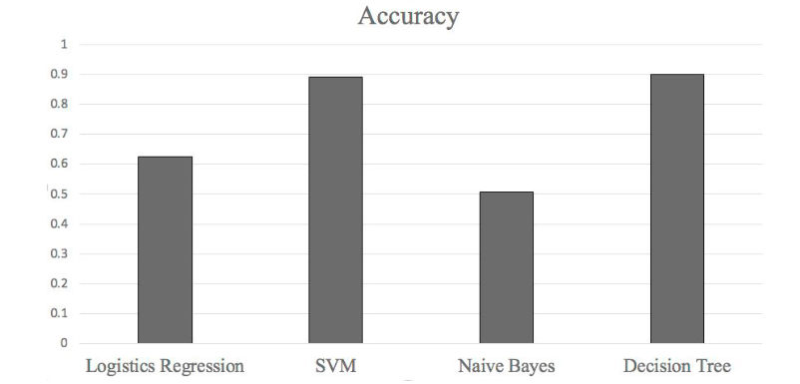
Fig. 17. Performance Results of Y.Yanying's Study.
In our FCDP-SFTS (Flight Cancellation Delay Prediction - Smart Flight Ticketing System) study, a more extensive data preprocessing and feature engineering process was applied, although similar data features and dataset were used. With the Decision Tree algorithm, an accuracy of 95% was achieved. These results show an improvement of 5% compared to the study in the literature.
In Giarmas' study, a dataset of 32,128,972 flights provided by the U.S. Department of Transportation on US domestic flights was used (Giarmas, 2019). The dataset covers flights between 2018 and 2022 and contains 121 different variables. Flight departure and arrival information, airline companies, time data and possible delay/interruption reasons are detailed. In particular, it was observed that ORD (Chicago O'Hare) airport has 1,499,216 flights and is among the most delayed airports.
In this study, various machine learning models were evaluated and their performances were compared in order to predict flight delays and cancelations. According to the findings, the Random Forest model was the most successful model in predicting flight delays with an accuracy of 77%. Alternatively, the XGBoost model gave satisfactory results with an accuracy of 73%, but did not perform as well as Random Forest in delay prediction. On the other hand, when the models for predicting flight cancelations were analyzed, it was determined that the Random Forest algorithm offered the highest performance with an accuracy rate of 83%. Table 11 and Table 12 show the performance results of this study.
Table 11
Flight Delay Model Performance Results of Giarmas' Study.
Model | Accuracy | Recall | Precision | F1 Score | AUC | RMSE | Execution Time
Decision Trees | 0.686545 | 0.666267 | 0.694655 | 0.680165 | 0.686555 | 0.559871 | 5.822055
Naive Bayes | 0.601815 | 0.556184 | 0.612306 | 0.582897 | 0.601837 | 0.631019 | 0.834699
Logistin Regression | 0.525055 | 0.517774 | 0.525677 | 0.521696 | 0.525059 | 0.689162 | 7.629777
XGBoost | 0.732887 | 0.689654 | 0.755148 | 0.720917 | 0.732908 | 0.516830 | 83.337318
SVM | 0.537776 | 0.521616 | 0.539294 | 0.530308 | 0.537784 | 0.679870 | 9.956836
Random Forest | 0.771258 | 0.722814 | 0.800560 | 0.759703 | 0.771282 | 0.478270 | 125.466779
KNN | 0.692317 | 0.616215 | 0.727104 | 0.667083 | 0.692354 | 0.554692 | 44.353603
Table 12
Flight Cancellation Model Performance Results of Giarmas' Study.
Model | Accuracy | Recall | Precision | F1 Score | AUC | RMSE | Execution Time
Decision Trees | 0.743762 | 0.739011 | 0.745426 | 0.742205 | 0.743754 | 0.506199 | 12.864707
Naive Bayes | 0.573631 | 0.434463 | 0.600788 | 0.504264 | 0.573388 | 0.652969 | 2.013837
Logistin Regression | 0.550082 | 0.526398 | 0.551661 | 0.538733 | 0.550041 | 0.670759 | 44.530750
XGBoost | 0.747930 | 0.757904 | 0.742439 | 0.750092 | 0.747947 | 0.502066 | 1381.146981
SVM | 0.797985 | 0.800399 | 0.795993 | 0.798190 | 0.797989 | 0.449461 | 326.619967
Random Forest | 0.556813 | 0.518243 | 0.560621 | 0.538599 | 0.556746 | 0.665723 | 421.932576
KNN | 0,745923 | 0.750650 | 0.742965 | 0.746788 | 0,745931 | 0.504061 | 113.055845

In our FCDP-SFTS (Flight Cancellation Delay Prediction - Smart Flight Ticketing System) study, despite using similar data set characteristics, the Random Forest model algorithm achieved 97% accuracy in flight cancelation. With the XGBoost model algorithm, 75% accuracy rate was achieved in flight delay. These results show a 17% improvement in flight cancelation and a 2% improvement in flight delay, respectively, compared to the study in the literature.
Ahlam Ansari et al. aimed to predict ticket cancellations using an airline dataset of Indian domestic flights (Ansari et al., 2019). The dataset contains various reservation-based features such as ticket price, booking date, number of passengers, and nationality of the passenger. In the feature engineering process, redundant components of the data were removed and only data pertaining to ticket bookings (AIR entries) were selected and analyzed.
Four different machine learning classification algorithms, namely Logistic Regression, Decision Trees, Random Forest and Gradient Boosting, were used in the study. The performance of the models was evaluated with metrics such as accuracy, precision, recall, F1 Score and ROC Curve.
The results show that the Decision Trees algorithm achieved the highest accuracy (97.43%) and performed the best. The Random Forest model performed well with an accuracy of 95.21% and a precision of 100%, but the recall remained at 90.43%. The Gradient Boosting algorithm provided a balanced performance with 96.83% accuracy and 93.82% recall. The Logistic Regression model performed worse than the other models with 88.67% accuracy, 97.66% precision, but 77.46% recall.
The findings revealed that Decision Trees and Gradient Boosting are the best models for ticket cancellation prediction. Table 13 shows the performance results of this study.
Table 13
Performance Results of Ansari's Study.
Model | Precision | Recall | F1-Score | ROC
Logistic Regression | 0.9766 | 0.7746 | 0.8640 | 0.8867
Decision Trees | 0.9716 | 0.9506 | 0.9609 | 0.9743
Random Forest | 1.0000 | 0.9043 | 0.9497 | 0.9521
Gradient Boosting | 0.9743 | 0.9382 | 0.9559 | 0.9683

In our FCDP-SFTS (Flight Cancellation Delay Prediction - Smart Flight Ticketing System) study, a comprehensive dataset including airline operation data, flight history and weather data is used to predict flight cancellations. In the feature engineering phase, flight-specific factors (e.g., departure and arrival points, flight distance, scheduled and actual departure times, weather conditions) were taken into account.
XGBoost, Random Forest, Decision Trees, KNN and Gradient Boosting were used as machine learning models and the performance evaluation was based on accuracy, precision, recall, F1 score and ROC-AUC metrics.
In our FCDP-SFTS study, XGBoost was the best performing model, while Decision Trees and Gradient Boosting also performed well. Compared to Ansari et al.'s study, despite using different datasets and features, the Decision Trees and Gradient Boosting models similarly provide high accuracy and balanced performance. However, the model offers a more comprehensive analysis by focusing on delay prediction as well as flight cancellations.
Accordingly, two separate tables have been prepared in order to perform a comparative analysis of both the findings of this study and similar studies in the literature. These tables provide a holistic evaluation by presenting the performance of the models in flight cancellation and delay forecasting together.
In Table 14, the accuracy and other key performance metrics of the models used for flight cancellation prediction are presented comparatively. In this table, both the results obtained in our study and the results of the examples in the literature are evaluated together. Thus, it is possible to observe how similar methods produce similar results even if different datasets and features are used.
Table 14
Mass Flight Cancellation Prediction Model Performance Comparison.
Study | Model | Accuracy | Precision | Recall | F1-Score
FCDP-SFTS | XGBoost | 0.97 | 0.98 | 0.99 | 0.98
Yu Yanying and colleagues | Decision Tree | 0.90 | - | - | -
Giarmas | XGBoost | 0.74 | 0.75 | 0.74 | 0.75
Ahlam Ansari and friends | Gradient Boosting | 0.97 | 0.93 | 0.95 | 0.96

Similarly, Table 15 shows the performance of the models for flight delay prediction in a comparative manner. This table analyzes the accuracy rates and balanced classification performances of various models focusing on delay prediction. This comparison reveals that the developed model can successfully predict not only cancellations but also delays and provides a more comprehensive solution compared to the studies in the literature.
Table 15
Batch Flight Delay Prediction Model Performance Comparison.
Study | Model | Accuracy | Precision | Recall | F1-Score
FCDP-SFTS | XGBoost | 0.75 | 0.84 | 0.99 | 0.84
Khaksar ve Sheikholeslami | Hybrid Method (Decision Tree + Clustering) | 0.71 | 0.94 | 0.79 | -
M. Kurt | XGBoost | 0.71 | - | 0,49 | 0.57
Ahlam Ansari and friends | Gradient Boosting | 0.73 | 0.68 | 0.75 | 0.72

  - Web Based Application Development - SmartTicket System

The machine learning-based flight cancellation and delay prediction models developed in this study are not only limited to theoretical analysis, but also integrated into an interactive web platform that allows users to directly access these predictions. This system, called SmartTicket (FCDP-SFTS AI Model Web Application), aims to provide decision support for travel planning processes by providing real-time flight forecasts to passengers.
SmartTicket is designed with a modular architecture consisting of three layers:
Frontend (React.js): The user interface provides visual presentation of flight search, ticket information and model predictions. Ant Design, Tailwind CSS and Framer Motion are used to create a modern and user-friendly experience.
Backend (Node.js/Express): RESTful service layer that fulfills user requests and manages data exchange with the model API. City, airport and flight data are provided here.
Model API (Python - Flask/FastAPI): Artificial intelligence models that provide cancellation and delay predictions are run in this layer, and prediction results are generated with trained models and transmitted to the client.
The user interface layer includes the main screen where passengers can query flights and view the forecast results in a visualized format. After selecting the departure and arrival cities, the user can list the flights offered in the relevant date range and see the cancellation and delay forecasts for each flight. Figure 18 shows a screenshot of the main page showing this functionality.

Fig. 18. Flight Search Screen (Home Page).
The main functionalities offered by the web platform are:
Flight Search and Forecast: Users can list flights by selecting departure/arrival cities and dates, and access forecast details for each flight.
The flights presented to the user as a result of the search are listed as ticket cards. These cards provide the user with basic data such as flight times, airline information, price, as well as the general cancellation and delay risk summary calculated by artificial intelligence for the relevant flight. The forecast details are initially hidden in a plain view; the user can view this information in detail if they wish. Figure 19 shows the tickets listed as a result of the search.
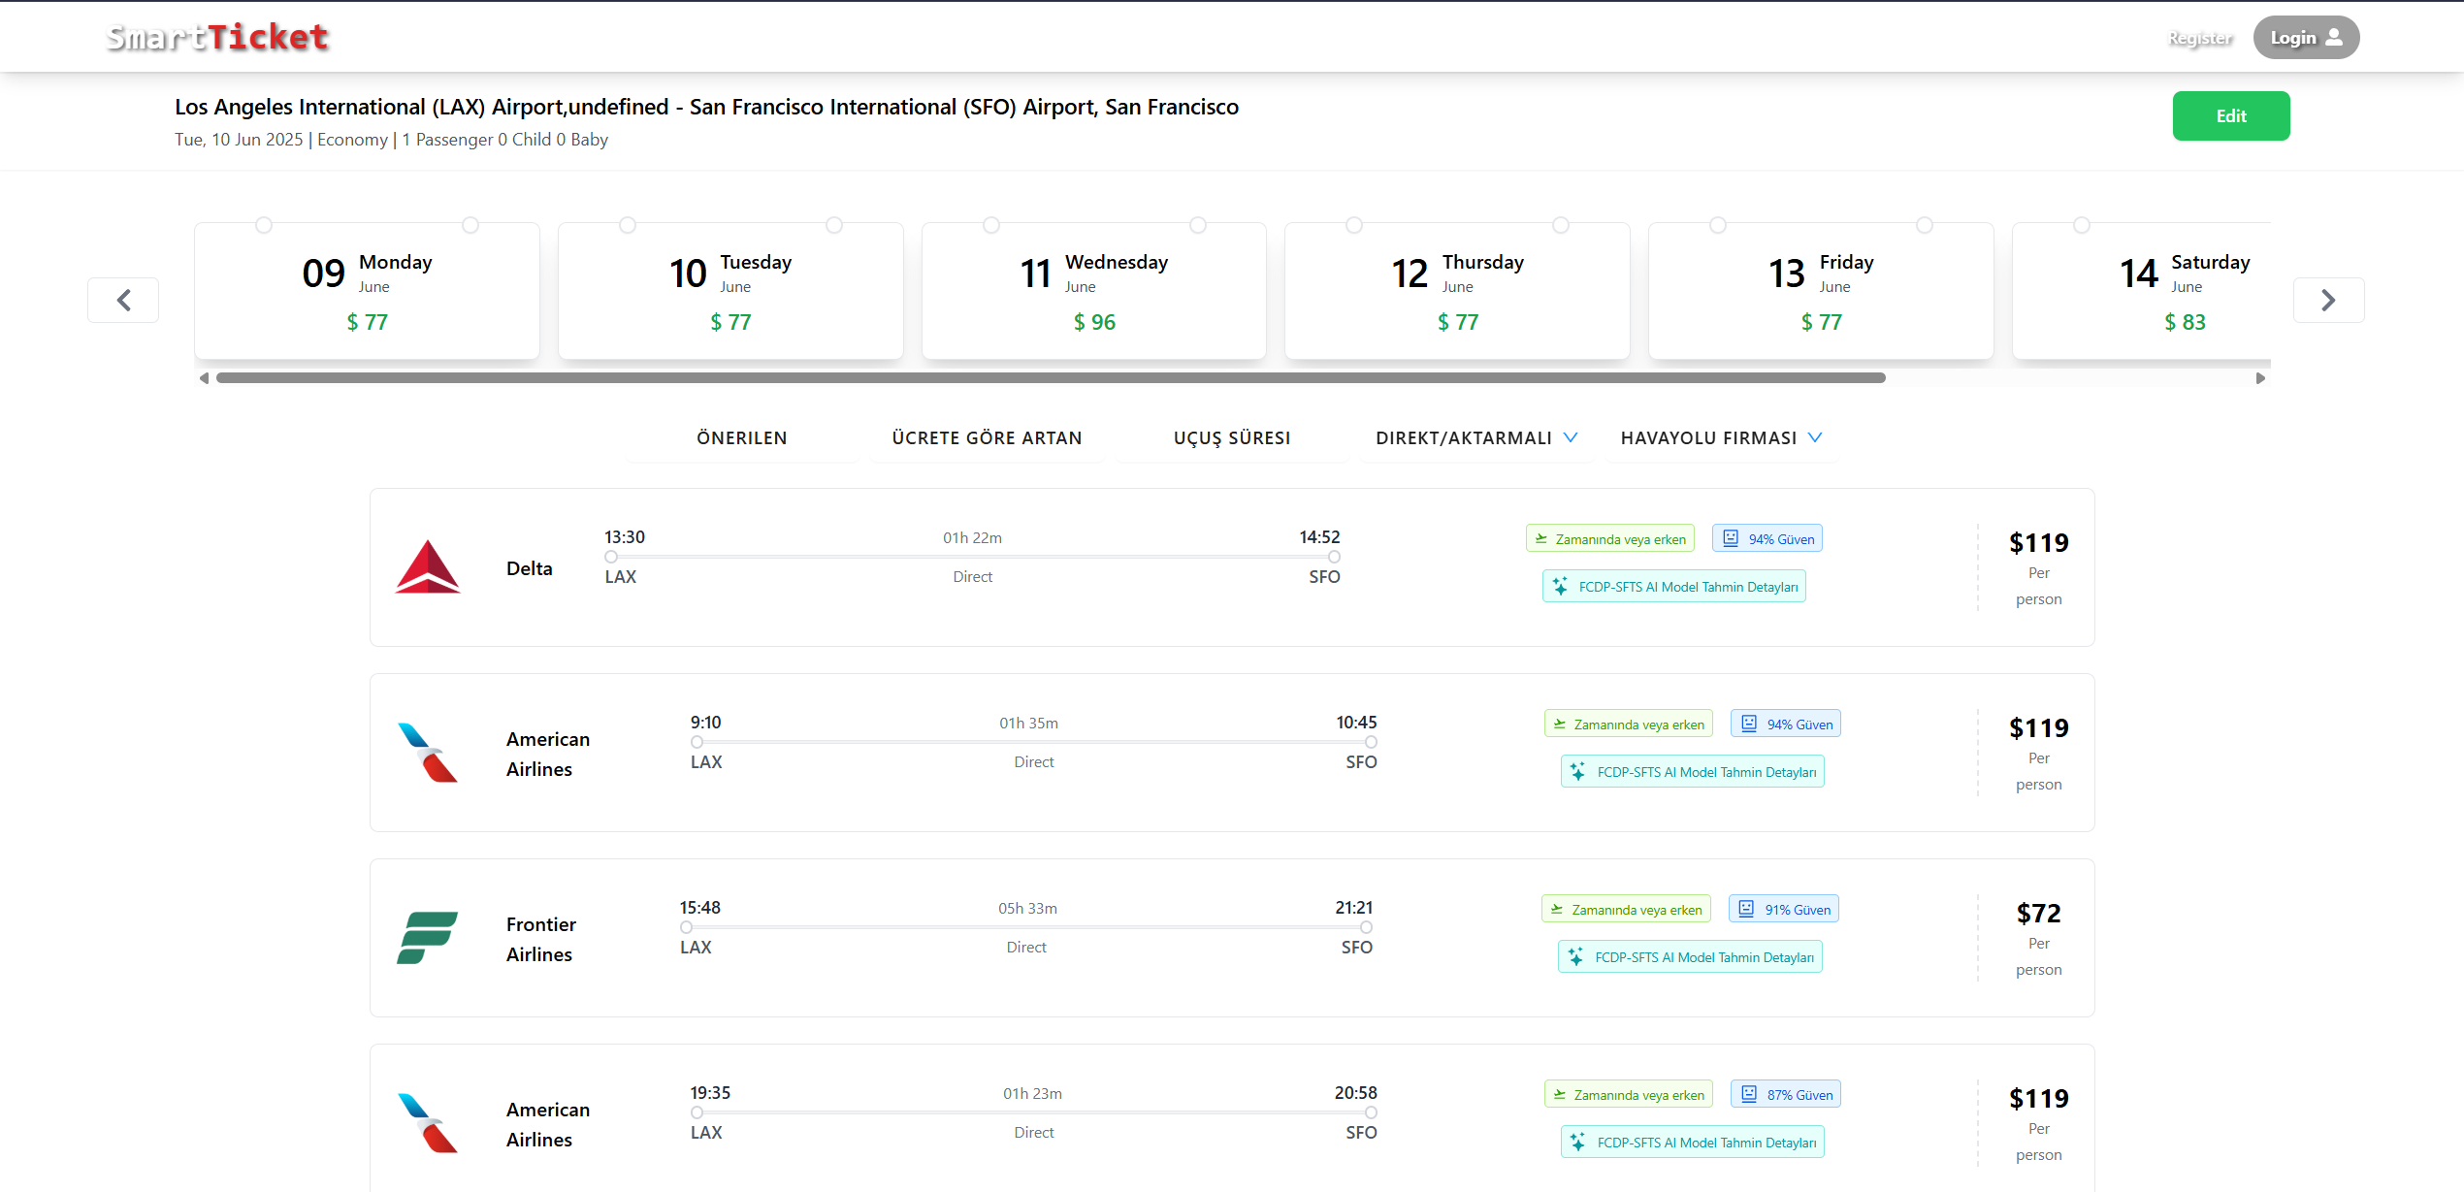
Fig. 19. Flight Tickets Listed in Search Result.
AI Forecast Visualization: Cancellation and delay probabilities are made easy to understand with the help of animated representations and colorful graphics.
By clicking on the "FCDP-SFTS AI Model Forecast Details" label on each flight card, the user can open the detailed analysis of the forecasts for the relevant flight. In the panel that opens, the probabilities of the flight being canceled and on time are visualized with colored bar graphs. Likewise, delays are also presented by categorizing them into estimated duration categories. This panel is also supplemented with text explaining the confidence of the model and the corrections made. Figure 20 shows the panel of forecast details.
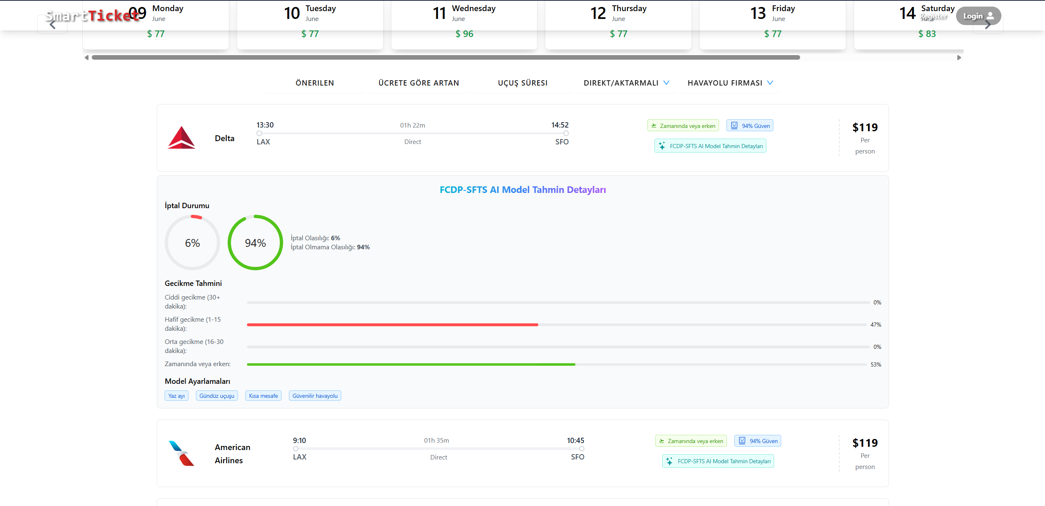
Fig. 20. AI Model Forecast Details.
Confidence and Disclosure: The confidence scores provided by the model for each prediction provide transparency to the user and allow the predictions to be evaluated with their reasons.
With this system, the practical applicability of the developed models was tested and it was demonstrated how a user experience-oriented artificial intelligence solution can be integrated for the airline industry.
Figure 21 shows the overall system architecture of the website. User requests are routed from the frontend to the backend and from there to the model API; the results are returned in the same chain.
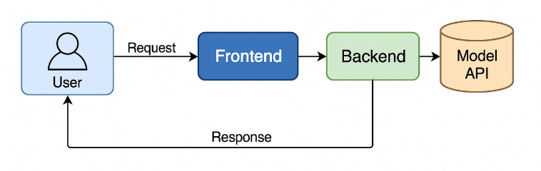
Fig. 21. SmartTicket System Architecture.
    - Prediction Reliability and Decision Threshold Mechanism

The predictions provided on the SmartTicket platform undergo a process that converts the model's probabilistic outputs into user-focused decision support information. The decision threshold mechanism applied for cancellation predictions has been set at 0.40 based on temporal validation results and operational cost analyses. This threshold value aims to minimize the false positive rate (unnecessary cancellation warnings) while keeping the false negative rate (missed cancellations) at an acceptable level. After calculating the cancellation probability, the model applies dynamic correction factors based on meteorological conditions (summer months, good weather), operational factors (daytime flights, short-haul routes), and airline reliability scores. These adjustments reduce the raw model output by 30% to 70%, preventing overly conservative predictions. In the user interface, the confidence score for each prediction is displayed as a percentage, and the applied adjustment factors are presented as labels in Figure 20 to ensure transparency.

    - Operational Impact Analysis of Incorrect Predictions

The model's prediction performance should be evaluated not only by accuracy metrics but also by the operational and economic consequences of incorrect predictions. False positive predictions (situations where a cancellation/delay is predicted but does not occur) can cause unnecessary anxiety among passengers, negatively impact the user experience due to searches for alternative flights, and create unnecessary load on airline reservation systems. However, since this provides passengers with early warning, it offers an opportunity to create a plan B. Based on the results obtained in the model's test set, the false positive rate for cancellation predictions was measured at 8%, while the false negative rate was 12%.
For delay predictions, the recall metric was measured at 73% for rare classes (severe delays, >30 minutes). Although this value indicates that 27% of critical delays are missed, it is acceptable in an operational context. This is because passengers will already be informed by standard airline notification systems in false negative cases; conversely, the 73% correctly identified by the system provides an opportunity for proactive planning. False positive delay predictions (e.g., a delay warning for a flight that departs on time) create a marginal inconvenience, such as passengers arriving at the airport earlier, but this does not lead to critical consequences like a missed flight. Therefore, the model prioritizes recall over precision in the precision-recall trade-off, optimizing the detection of minority classes.

    - Real-Time Weather Integration and Forecast Accuracy

One of the most significant innovations of the SmartTicket platform is that predictions are supported not only by historical data but also by real-time meteorological data. When a user selects a flight, the system retrieves current weather parameters (temperature, precipitation, wind speed, etc.) for the selected date and airport location via the Meteostat API and sends a request to the model API with this data. This approach goes beyond forecasts based on static training data, enabling the modeling of the impact of current weather conditions on flight operations. For example, a route with a low cancellation risk under normal conditions in summer can be reassessed with dynamically updated weather data if heavy precipitation is forecast for the day of the prediction. This integration increases the model's generalization capacity and enables adaptation to changing environmental conditions over time.
The SmartTicket platform concretizes the transformation of machine learning models' theoretical performance into real-world applications. The system not only provides forecasts but also transparently communicates to the user the reliability level of the forecasts, their operational context, and the potential impact of incorrect forecast scenarios. This both tests the practical value of research outputs and provides a concrete application for increasing sectoral benefits.

Discussion and implications

This study presents advanced machine learning and deep learning approaches for predicting flight cancellations, cancellation reasons, and flight delays in the aviation sector. The high success rates achieved demonstrate that the developed models can be effectively used to solve prediction problems in the aviation sector. The innovative methodologies and techniques presented in our study contribute to the academic literature and offer practical applications for airlines, airport management, and passengers.
During the modeling process, algorithms such as XGBoost, Random Forest, Decision Tree, K-Nearest Neighbors (KNN), and Gradient Boosting were compared, and the models with the best performance were identified. The results obtained showed that:
The flight cancellation prediction model produced successful results in terms of accuracy and other metrics, with the XGBoost algorithm demonstrating the best performance with a 97% accuracy rate.
The cancellation code prediction model provided satisfactory results in determining the reasons for canceled flights, with XGBoost showing higher performance compared to other algorithms with an accuracy rate of 74%.
The flight delay prediction model provided a reasonable accuracy rate in determining flight delays, but it revealed the need for a more detailed examination of variables such as weather, air traffic, and operational factors.
Among the innovations provided by this study are the creation of a more comprehensive dataset by combining open data from different sources, the modeling of different delay and cancellation reasons, and the determination of the most suitable method by comparing multiple machine learning algorithms.
Future studies could take further steps in solving forecasting problems in the aviation sector by developing more comprehensive datasets, real-time forecasting systems, explainable artificial intelligence approaches, and human-machine collaboration systems. This study is expected to contribute to increasing operational efficiency in the aviation sector, improving the passenger experience, and enhancing the overall performance of the sector.

Conclusion and future work

In this study, machine learning models were developed to predict flight delays and cancellations by integrating historical flight data with meteorological data. In the future, it is planned to integrate dynamic variables such as real-time weather conditions, flight traffic density, and airport operational data into the system to further improve the model's prediction performance. Furthermore, in addition to the classification algorithms used in the model, it is intended to test time series-focused deep learning approaches such as LSTM and GRU. To increase the model's explainability, interpreting important features using methods such as SHAP (SHapley Additive exPlanations) will also be evaluated in further analyses. On the web platform side, an interactive and user-friendly interface is planned to be designed where users can query their flights and view prediction results with graphics, as well as receive alternative flight and price suggestions. Furthermore, integrating AI-supported recommendation systems that will enable continuous updating of the model by receiving user feedback is among the developments to be focused on in later stages.

References

Li, N., & Yao, H. G. (2025). A review of research on flight delay propagation: Current situation and prospect. Journal of Advanced Transportation, Article 4851103. https://doi.org/10.1155/atr/4851103
Çalış, A., Durmaz, K. İ., & Gencer, C. (2018). Uçak seferlerindeki rötarları etkileyen faktörlerin analizi. Uluslararası İktisadi ve İdari İncelemeler Dergisi, (20), 179–190. https://doi.org/10.18092/ulikidince.353973
U.S. Department of Transportation. (2024, April). Air travel consumer report: December 2023 and full year 2023 numbers. https://www.transportation.gov/briefing-room/air-travel-consumer-report-december-2024-full-year-2024-numbers
AirHelp. (2024). Over 45 million UK passengers faced disruptions in 2023. https://www.airhelp.com/en-int/press/airhelp-reveals-that-over-45-million-uk-passengers-faced-disruptions-in-2023/?utm_source=chatgpt.com
L’heureux, A., Subramanian, D., Ghosh, R., & Krishnamurthy, R. (2017). Machine learning with big data: Challenges and approaches. IEEE Access, 5, 7776–7797.
Bentéjac, C., Csörgő, A., & Martínez-Muñoz, G. (2019). A comparative analysis of XGBoost. arXiv preprint, arXiv:1911.01914.
Dumitrascu, B., & Aiordachioaie, D. (2022). On data preprocessing for an improved performance of the sources classification. In 2022 IEEE 28th International Symposium for Design and Technology in Electronic Packaging (SIITME) (pp. 61–64). https://doi.org/10.1109/SIITME56728.2022.9988325
Bartle, J. R., Lutte, R. K., & Leuenberger, D. Z. (2021). Sustainability and air freight transportation: Lessons from the global pandemic. Sustainability, 13(7), 3738. https://doi.org/10.3390/su13073738
Ghosh, B., & Tabrizi, B. (2018). Machine learning approaches for flight delay prediction: A review. International Journal of Aviation Studies, 5(3), 123–134.
Delahaye, D., & Puechmorel, S. (2020). Weather impact on flight delay prediction: An AI-based approach. Journal of Transportation Research, 12(4), 256–268.
Chawla, N. V., Bowyer, K. W., Hall, L. O., & Kegelmeyer, W. P. (2002). SMOTE: Synthetic minority over-sampling technique. Journal of Artificial Intelligence Research, 16, 321–357.
Eurocontrol. (2019). European aviation in 2040: Challenges of growth. Performance Review Commission, Eurocontrol Performance Review Unit.
Fernández, A., García, S., Galar, M., Prati, R. C., Krawczyk, B., & Herrera, F. (2018). Learning from imbalanced data sets. Springer International Publishing.
Kim, Y. J., Choi, S., Briceno, S., & Mavris, D. (2016). A deep learning approach to flight delay prediction. In 2016 IEEE/AIAA 35th Digital Avionics Systems Conference (DASC) (pp. 1-6). IEEE.
Khaksar, H., & Sheikholeslami, A. (2017). Airline delay prediction by machine learning algorithms. Scientia Iranica.
Ye, B., Liu, B., Tian, Y., & Wan, L. (2020). A methodology for predicting aggregate flight departure delays in airports based on supervised learning. Sustainability, 12(7), 2749.
Atlıoğlu, M. C., Bolat, M., Şahin, M., Tunalı, V., & Kılınç, D. (2020). Supervised learning approaches to flight delay prediction. Sakarya University Journal of Science.
Al-Tabbakh, M. S., Mohamed, H. M., & El, Z. H. (2018). Machine learning techniques for analysis of Egyptian flight delay. International Journal of Data Mining & Knowledge Management Process, 8(3), 1–14.
Kurt, M. (2019). Flight delay prediction [Capstone project, MEF University].
Tang, Y. (2021). Airline flight delay prediction using machine learning models. In 5th International Conference on E-Business and Internet (pp. 151–154). Singapore.
Zelaya, P. (2023). Flight delay and cancellation dataset (2019–2023) [Dataset]. Kaggle. https://www.kaggle.com/datasets/patrickzel/flight-delay-and-cancellation-dataset-2019-2023
Threnjen. (2019). 2019 airline delays and cancellations [Dataset]. Kaggle. https://www.kaggle.com/datasets/threnjen/2019-airline-delays-and-cancellations
Singh, S. (2024). Flight delay dataset (2018–2024) [Dataset]. Kaggle. https://www.kaggle.com/datasets/shubhamsingh42/flight-delay-dataset-2018-2024
Oladipupo, O. T. (2010). Types of machine learning algorithms. In New Advances in Machine Learning.
Kumar, R., & Singh, N. (2020). A survey on data mining and machine learning techniques for flight delay prediction. International Journal of System Assurance Engineering and Management.
Breiman, M. (1984). Classification and regression trees. Wadsworth and Brooks/Cole.
Ke, G., Meng, Q., Zhang, T., Chen, W., & Liu, T. (2017). LightGBM: A highly efficient gradient boosting decision tree. Microsoft Research.
Breiman, L. (2001). Random forests. Machine Learning, 45(1), 5–32.
Kim, Y., Mavris, D. N., & Zachariah, J. (2021). Impacts of weather on airline performance metrics: A data-driven analysis. Transportation Research Part D: Transport and Environment, 92, 102740.
Chen, T., & Guestrin, C. (2016). XGBoost: A scalable tree boosting system. In Proceedings of the 22nd ACM SIGKDD International Conference on Knowledge Discovery and Data Mining (pp. 785–794).
Yu, Y., Mo, H., & Li, H. (2019). A classification prediction analysis of flight cancellation based on Spark. In 7th International Conference on Information Technology and Quantitative Management (ITQM 2019), Procedia Computer Science, 162, 480–486. https://doi.org/10.1016/j.procs.2019.12.014
Giarmas, N. (2025). Flight delay and cancellation prediction using machine learning models (Master’s thesis, Department of Business Administration, Business Analytics and Data Science).
Ansari, A., Shaikh, A., Mapkar, S., & Khan, M. (2019). Cancellation prediction for flight data using machine learning. In 2nd International Conference on Advances in Science & Technology (ICAST-2019), K. J. Somaiya Institute of Engineering & Information Technology, University of Mumbai, Maharashtra, India. SSRN.
Alfarhood, M., Alotaibi, R., Abdulrahim, B., Einieh, A., Almousa, M., & Alkhanifer, A. (2024). Predicting flight delays with machine learning: A case study from Saudi Arabian Airlines. International Journal of Aerospace Engineering, 2024, 1–11. https://doi.org/10.1155/2024/3385463
Hake, P. S., Parjane, P. P., Parte, S. S., Subhedar, L. S., & Dimbale, N. (2024). Aero Predict & Flight Booking. Navsahyadri Education Society’s Group of Institutes.
Barua, B., & Kaiser, M. S. (2024). A next-generation approach to airline reservations: Integrating cloud microservices with AI and blockchain for enhanced operational performance. arXiv preprint, arXiv:2411.06538. https://doi.org/10.48550/arXiv.2411.06538
Mueller, E. R., & Chatterji, G. B. (2020). Predicting flight delays and cancellations using machine learning: Evidence from Heathrow Airport operations. Research in Transportation Business & Management, 37, 100543. https://doi.org/10.1016/j.rtbm.2020.100543
Abdelghany, A., Khan, W. A., Chung, S.-H., Eltoukhy, A. E. E., & Khurshid, F. (2023). A novel parallel series data-driven model for IATA-coded flight delays prediction and features analysis. Research in Transportation Business & Management, 49, 100874. https://doi.org/10.1016/j.rtbm.2023.100874
Truong, D. (2020). Causal machine learning approaches for flight delay risk analysis in airline planning. Research in Transportation Business & Management, 37, 100551. https://doi.org/10.1016/j.rtbm.2020.100551
Wang, H., Wang, Y., & Wang, K. (2021). Flight delay prediction based on spatio-temporal correlation and deep learning: A CNN-LSTM approach. Research in Transportation Business & Management, 41, 100626. https://doi.org/10.1016/j.rtbm.2021.1006
Gama, J., Žliobaitė, I., Bifet, A., Pechenizkiy, M., & Bouchachia, A. (2014). A survey on concept drift adaptation. ACM Computing Surveys (CSUR), 46(4), 1-37.
Sokolova, M., & Lapalme, G. (2009). A systematic analysis of performance measures for classification tasks. Information Processing & Management, 45(4), 427-437.
He, H., & Garcia, E. A. (2009). Learning from imbalanced data. IEEE Transactions on Knowledge and Data Engineering, 21(9), 1263-1284.
He, H., Bai, Y., Garcia, E. A., & Li, S. (2008). ADASYN: Adaptive synthetic sampling approach for imbalanced learning. In 2008 IEEE International Joint Conference on Neural Networks (IEEE World Congress on Computational Intelligence) (pp. 1322-1328). IEEE.
Elkan, C. (2001). The foundations of cost-sensitive learning. In International Joint Conference on Artificial Intelligence (Vol. 17, No. 1, pp. 973-978). Lawrence Erlbaum Associates Ltd.
Lu, J., Liu, A., Dong, F., Gu, F., Gama, J., & Zhang, G. (2018). Learning under concept drift: A review. IEEE Transactions on Knowledge and Data Engineering, 31(12), 2346-2363.
Cerqueira, V., Torgo, L., & Mozetič, I. (2020). Evaluating time series forecasting models: An empirical study on performance estimation methods. Machine Learning, 109(11), 1997-2028.

